
Intelligent Question Answering System for University Policy Documents
BY
OBIORA ORAKWUE
20221870

SUPERVISED BY
PROF NOAH AKANDE
A PROJECT SUBMITTED TO THE DEPARTMENT OF COMPUTER SCIENCE, FACULTY OF COMPUTING, NILE UNIVERSITY OF NIGERIA. IN PARTIAL FULFILMENT FOR THE AWARD OF BARCHELOR OF SCIENCE HONOURS (B.Sc. HONS) DEGREE IN COMPUTER SCIENCE

JUNE, 2026

DECLARATION
I hereby declare that this project titled [PROJECT TITLE] is my original work and has not been presented for any other qualification anywhere. Information from other sources (published or unpublished) has been duly acknowledged.

_____________________ __________________
[STUDENT NAME] SIGNATURE/DATE
[STUDENT ID]

CERTIFICATION
This is to certify that this final project titled [INTELLIGENT QUESTI] was undertaken by [STUDENT NAME] with student ID Number [STUDENT ID] has been read and approved by the undersigned signatories for meeting the requirements for the award of BACHELOR OF SCIENCE HONORS (B.SC. HONS) IN COMPUTER SCIENCE by the DEPARTMENT OF COMPUTER SCIENCE.

PROF NOAH AKANDE _______________________
PROJECT SUPERVISOR SIGNATURE & DATE

ASSOC. PROF. MUHAMMAD ALIYU. SULEIMAN ________________________
HOD, COMPUTER SCIENCE DEPARTMENT SIGNATURE & DATE

PROF. JOSHUA ABBAH ________________________
DEAN, FACULTY OF COMPUTING SIGNATURE & DATE

ASSOC. PROF. ALHASSAN ADAMU _______________________
EXTERNAL SUPERVISOR SIGNATURE & DATE

DECLARATION
I, OBIORA ORAKWUE, a final year student in the Department of Computer Science, Faculty of Computing, Nile University of Nigeria, Abuja, hereby declare that this project entitled "Intelligent Question Answering System for University Policy Documents" submitted in partial fulfilment of the requirements for the award of Bachelor of Science (B.Sc.) Degree in Computer Science is based on my actual and original work. Any materials obtained from other sources or work done by any other person or institutions have been duly acknowledged.
I further declare that this work has not been previously submitted to any other university for the award of any degree or diploma.
___________________
OBIORA ORAKWUE
Date: 14/05/2026
20221870

CERTIFICATION
This is to certify that this Project was undertaken Obiora Orakwue 20221870 and has been read and approved by the undersigned signatories for meeting and requirement for the award of Bachelor of Science Honors (B.Sc. Hons) in Computer Science by the Department of Computer Science, Nile University of Nigeria, Abuja.
___________________
DR. AHMED ADENEYI
DATE:
PROJECT SUPERVISOR
___________________
PROF. MUHAMMAD A. SULEIMAN
HOD. COMPUTER SCIENCE DEPARTMENT

__________________
PROF. JOSHUA ABBAH
DATE:
DEAN OF FACULTY OF COMPUTING

___________________
DATE:
EXTERNAL SUPERVISOR

DEDICATION
This project is dedicated to Almighty God for His infinite grace and guidance throughout my academic journey.
I also dedicate this work to my beloved parents and family, whose unwavering support, encouragement, and sacrifices have made this achievement possible.

ACKNOWLEDGEMENT
All praise and gratitude belong to Almighty God, the most gracious and most merciful, for granting me the strength, knowledge, and perseverance to complete this project successfully.
I wish to express my deepest gratitude to my supervisor, Dr. Ahmed Adeneyi, for his invaluable guidance, constructive criticism, patience, and encouragement throughout the course of this research. His expertise and dedication have been instrumental in shaping this work to its present form.
My sincere appreciation goes to the Head of Department, Prof. Noah Akande, and all the faculty and staff of the Department of Computer Science, Nile University of Nigeria, for their support and for providing a conducive learning environment. I am particularly grateful to my lecturers who have imparted knowledge and skills that laid the foundation for this project.
I am also thankful to my colleagues and friends who shared ideas, offered feedback, and helped shape this project through thoughtful discussions. Your contributions have been invaluable.
Special thanks go to my family, especially my parents, for their endless love, prayers, financial support, and belief in me throughout this journey. Your sacrifices have not gone unnoticed.
Finally, I acknowledge all the authors whose works I have cited in this research. Their contributions to the field of natural language processing and question answering systems have been the foundation upon which this project is built.
Thank you all.
OBIORA ORAKWUE
May, 2026

ABSTRACT
University policy documents such as student handbooks and academic regulations are essential for academic administration. However, students and staff struggle to locate specific information within these lengthy documents. Traditional keyword search fails to understand user intent, while manual searching is time-consuming. This research focused on designing an Intelligent Question Answering System for University Policy Documents using a Retrieval-Augmented Generation (RAG) approach with the GPT-3.5-turbo language model.
The objectives were to: (i) explore existing question answering systems; (ii) preprocess university policy documents; (iii) optimize a GPT-3.5-turbo (RAG) model for generative question answering; (iv) develop a system that accepts natural language queries; and (v) evaluate the system's performance.
The backend implemented a document processing pipeline that extracted text from PDF policy documents. A total of 460 pages across eight policy documents were processed, yielding 14,254 sentences. The GPT-3.5-turbo model was integrated within a RAG architecture using LlamaIndex for retrieval.
The evaluation used a test dataset of 150 question-answer pairs across six policy categories. The system achieved an exact match accuracy of 76.67% and an F1 score of 82.34%. Compared to keyword-based search, the system showed a 35.34% higher exact match accuracy. The average response time was 1.84 seconds.
The study concluded that the RAG-based question answering system effectively retrieves information from university policy documents, outperforming traditional keyword search by understanding semantic intent.
Keywords: Question Answering System, Retrieval-Augmented Generation, GPT-3.5-turbo, Natural Language Processing, University Policy Documents

Table Of Content
DECLARATION 1
CERTIFICATION 2
DEDICATION 3
ACKNOWLEDGEMENT 4
ABSTRACT 5
Table Of Content 6
Table Of Figures 7
Table Of Tables 8
Chapter One - Introduction 9
1.0 Introduction 9
1.1 Background of Study 10
1.2 Problem Statement and Research Questions 11
1.2.1 Problem Statement 11
1.3 Significance of Study 12
1.4 Aim and Objectives of the Study 12
1.4.1 Study Aim 12
1.5 Scope and Limitation of the Study 12
1.5.1 Scope of the Study 13
1.5.2 Limitations of the Study 13
1.6 Organization of the Study 14
Chapter Two 15
Literature Review 15
2.0 Concept of Artificial Intelligence 15
2.1 Natural Language Processing 16
2.2 Evolution of Question Answering Systems 16
2.3 Transformer Architecture 16
2.4 Bidirectional Encoder Representations from Transformers (BERT) 17
2.5 GPT-3.5-turbo (RAG) and Model Optimization 17
2.6 Generative Question Answering 17
2.7 Document-Based Question Answering Systems 18
2.8 Limitations of the Existing System 18
2.9 Related Works 18
2.11 Summary of Literature Review 27
CHAPTER 3 30
System Analysis and Design 30
3.0 Introduction 30
3.1 System Analysis 30
3.2 Analysis of Existing System 30
3.3 Justification for the New System 31
3.4 Description of New System 31
3.5 Design of Proposed System 31
3.5.1 Data Model 31
3.5.2 Functional Requirements 32
3.5.3 Use Case Diagram 33
3.5.4 Level 0 Data Flow Diagram 33
3.5.5 Level 1 Data Flow Diagram 33
3.5.6 Database Model 34
3.5.7 Sequence Diagram 35
3.5.9 Class Diagram 36
3.5.10 System Architecture 37
3.5.11 Deployment Diagram 38
3.5.11 Software Structure 38
3.5.12 Workflow of Use Cases 38
3.6 Functional and Non-Functional Requirements 40
3.6.1 Functional Requirements 40
3.6.2 Non-Functional Requirements 40
3.7 Data Collection 41
CHAPTER FOUR - RESULTS AND DISCUSSION 41
4.1 Introduction 42
4.2 System Implementation Results 44
4.2.1 Document Processing Pipeline 44
4.2.2 GPT-3.5-turbo (RAG) Model Fine-Tuning Results 46
4.2.3 User Interface Implementation 48
4.3 Performance Evaluation Results 48
4.3.1 Evaluation Dataset 49
4.3.2 Performance Metrics 49
4.3.3 Overall System Performance 49
4.3.4 Performance by Question Category 50
4.3.5 Comparison with Baseline Keyword-Based Search 51
4.3.6 Confidence Score Analysis 52
4.3.7 Handling of Out-of-Domain Questions 53
4.4 Research Questions Analysis 54
4.5 Discussion of Findings 55
4.5.1 Interpretation of Results 55
4.5.2 Comparison with Related Work 56
4.5.3 Strengths of the Proposed System 56
4.5.4 Limitations Observed During Evaluation 57
4.6 Summary of Major Findings 57
CHAPTER FIVE - SUMMARY, CONCLUSION, AND RECOMMENDATIONS 58
5.1 Summary 59
5.2 Conclusion 60
5.3 Recommendations 62
5.4 Contributions to Knowledge 64
5.5 Suggestions for Further Studies 66
REFERENCES 67

Table Of Figures

Figure 3.1 ................................................................................................................................ 37
Figure 3.2 ................................................................................................................................ 38
Figure 3.3 ................................................................................................................................ 38
Figure 3.4 ................................................................................................................................ 39
Figure 3.5 ................................................................................................................................ 40
Figure 3.6 ................................................................................................................................ 41
Figure 3.7 ................................................................................................................................ 42
Figure 3.8 ................................................................................................................................ 44
Figure 4.1 ................................................................................................................................ 51
Figure 4.2 ................................................................................................................................ 52
Figure 4.3 ................................................................................................................................ 53
Figure 4.4 ................................................................................................................................ 57
Figure 4.5 ................................................................................................................................ 58

Table Of Tables

Table 4.1 ................................................................................................................................ 50
Table 4.2 ................................................................................................................................ 53
Table 4.3 ................................................................................................................................ 55
Table 4.4 ................................................................................................................................ 56
Table 45 ................................................................................................................................ 59
Table 4.6 ................................................................................................................................ 61

CHAPTER ONE

INTRODUCTION

1.0 Introduction
The administration of modern higher education institutions is governed by an extensive and complex framework of official policies, guidelines, regulations, and procedures. These institutional documents—ranging from comprehensive undergraduate student handbooks, academic regulations, and examination policies, to departmental guidelines and codes of conduct—serve as the operational foundation for academic and administrative decision-making. They are designed to guarantee transparency, equity, and consistency across all university operations, providing students and staff with a clear roadmap of their rights, responsibilities, and institutional requirements. Consequently, the ability of university stakeholders to easily access, interpret, and comply with these policies is crucial for maintaining academic integrity, optimizing administrative efficiency, and fostering a supportive student experience.
However, the sheer volume, length, and dense bureaucratic language of these documents often present a significant barrier to effective information retrieval. Traditional institutional databases typically store these documents as large, monolithic PDF files or physical brochures. When students or staff members need to resolve specific, time-sensitive queries—such as course registration deadlines, graduation requirements, examination regulations, or grading appeal procedures—they are forced to manually sift through hundreds of pages of text or rely on basic, keyword-based search engines. These legacy search engines frequently fail to capture the semantic context of a user's question, leading to irrelevant search results or missing critical details when users express their queries using synonyms or natural phrasing. This search friction often results in student frustration, non-compliance with academic rules, or an administrative bottleneck, as students resort to visiting administrative offices in person for routine questions.
To address these challenges, recent advancements in Artificial Intelligence (AI) and Natural Language Processing (NLP) offer a transformative paradigm. The evolution of large language models (LLMs) and dense vector embeddings has paved the way for semantic search systems that can comprehend the actual meaning behind natural language queries. Specifically, Retrieval-Augmented Generation (RAG) has emerged as a state-of-the-art framework that bridges the gap between pre-trained language models and private, domain-specific document repositories. By indexing document chunks as mathematical vector embeddings in a dedicated vector database and retrieving only the most semantically relevant context at query time, RAG-enabled conversational agents can generate accurate, contextually grounded answers that cite official sources, thereby mitigating the risk of factual hallucinations.

This study proposes the design, development, and evaluation of an Intelligent Question Answering System for University Policy Documents. The system leverages the orchestration capabilities of LlamaIndex, the efficient storage of ChromaDB, and the advanced reasoning capabilities of the Google Gemini 2.5 Flash model. By implementing this system, the research aims to provide university stakeholders with an interactive, natural-language interface that delivers immediate, accurate, and contextually relevant answers grounded in official university policies, thereby reducing administrative workloads and enhancing information accessibility.
This dissertation is structured into five distinct chapters. Chapter One introduces the research, outlining the background of the study, the problem statement, research questions, the study's aim and objectives, significance, scope, and limitations. Chapter Two provides a detailed literature review of relevant question answering technologies, NLP methods, and RAG architectures. Chapter Three presents the design and architectural framework of the proposed system. Chapter Four details the implementation, testing, and evaluation of the system's performance. Finally, Chapter Five concludes the study with a summary of findings and recommendations for future research.

1.1 Background of Study
There are a variety of official documents that govern the University environment; academic rules, administrative procedures and policies are some of those documents. These include students' handbooks, academic policies, departmental policies, policies on examinations, and codes of conduct. They are meant in such a way that they are consistent, transparent and just in their handling of academic and administrative affairs. In the case of students, the documents are used as the main sources of information on their rights, duties, and academic needs. They are relevant but information about them is generally not readily available in policy documents in Universities. Most of these documents are lengthy taking dozens or even hundreds of pages and they are written using formal language which is not easily comprehended by all users.
Those students who need to find the answer of some questions, like when they need to register their courses, examine or graduated, can hardly get the answer of some questions within a short time. This means that users are likely to need to spend a considerable amount of time to locate the information they require in documents or turn to unofficial sources that can have inaccurate information. With the advancement of Artificial Intelligence (AI) and Natural Language Processing (NLP), today, it is possible to enrich the interaction with the very large text documents. They can assist a computer in understanding and interpreting human speech and can assist a person in creating a computer-based system that has reasoning capabilities about the users' question. One of the important applications of NLP is Question Answering (QA) systems, which enable the user to ask questions in natural language and get a direct answer in the form of questions, which are extracted from a document or a database. That has been bolstered by recent advances in deep learning that have led to more powerful modern QA systems, such as transformational models like BERT and its derivatives. Gemini 2.5 Flash (RAG) is a highly efficient, state-of-the-art multimodal large language model that delivers high accuracy while minimizing local computing resource requirements by running via lightweight cloud API calls. This makes it highly suitable for real-time academic environments where performance and speed are crucial. The project thus incorporates policy-level NLP techniques that are applied to policy documents at the university to improve accessibility to information that would otherwise be hard to locate and reduce stress of manual searching.

1.2 Problem Statement
Whilst easy to access, university policy documents are not always user friendly with respect to accessing information. Students and members of staff tend to have a problem in finding particular answers in large and unorganized documents. Manual reading takes time and the simple key word search engines do not always yield the right information, or, don't try to grasp the meaning of the query given by the user. This may cause confusion, misreading of the policies and/or non-compliance with the policies that apply.
If it is not possible to have a smart system in place which can be used to answer queries in natural language, then users will usually have to go to administrative offices to seek clarity. This reliance adds up the amount of work of the administrative staff and delays communication in the institution. Moreover, misinformation can be caused by inconsistent responses of various sources. The problems featured here demonstrate the need for a system that can automatically be able to extract appropriate and contextually relevant answers from official documents.

1.3 Aim and Objectives of the Study
This part provides a general purpose of the research and the specific purposes that are required to achieve the overall purpose.

1.3.1 Study Aim
This project will focus on designing and deploying an AI-based Question Answering System, which is based on the transformer-based natural language processing methods to give correct and context-relevant responses to queries on policy documents within the university.
1.3.2 Objectives
The following objectives will be followed in the research to achieve the above purpose:
- To analyse the different question answering systems and natural language processing techniques available.
- To design an architecture that processes policy documents in a University in a way that can be leveraged efficiently in a machine-learning-based system.
- To develop a system that will accept natural language queries and give the appropriate answers
- To assess the system performance in terms of accuracy, relevance and usability

1.4 Significance of Study
The impact of this research is clear due to showing the potential application of the modern AI in solving a practical problem in the context of the problem of the university. The project can enhance the access to information for students and teachers by creating a system that can directly access the policy document when responding to questions with Natural Language. It also eliminates the reliance of administration staff on administrative enquiries and hence enhances the efficiency of the institutions.
From a technical perspective, the project will make its contribution to the use of transformer-based models in document-based information retrieval. It can also be used in future research and development of the AI-based system in the learning institutions, especially in developing countries where the availability of information is an issue in most cases.

1.5 Scope of the Study
The main goal of this project is to build a generative Question Answering System for the policies of English-language universities. Documents on which the system concentrates are like student handbooks and academic regulations and are meant to get answers directly through them. In the paper, the application of transformer-based models is highlighted particularly Gemini 2.5 Flash (RAG) in a scholarly context, while it does not have an external scope such as knowledge bases or search engines.

1.6 Limitations of the Study
Although the proposed system is effective, the study has some limitations which can be categorized into technical, data related and operational limitations.
- Technical Limitations: RAG pipelines rely on text chunking because large language models, despite having large context windows, can face context dilution or 'lost in the middle' phenomena when processing very long inputs. Dividing policy documents into chunks can occasionally lead to a loss of overall semantic context if information is split across boundaries. Moreover, while Gemini 2.5 Flash offers low latency and cost-effective API access, cloud-based dependencies introduce potential network latency and API availability requirements compared to local execution.
Note that the system is also an generative Question Answering model, which means that the system can only give an answer that can be found literally in the source documents. It is not able to come up with new explanations or to extrapolate on information that is not given. Furthermore, the performance of the system may vary depending on the limitations of the hardware can be experienced particularly on a machine having a limited processing power
- Data-Related Limitations: The quality, structure and fullness of the university policy documents used are key determinants of the accuracy and reliability of the system. Documentation that contains unclear terms, outdated policies, or different formatting can have a negative impact on the accuracy of the responses. In addition, it is only accessible to those who may need or want it in English, thus excluding the majority of people.
- Operational and Social Limitations: In terms of operations, it would be adopted easily depending on the level of familiarity and trust of the users to the AI based solution. Some users might be more inclined towards a more conventional method of information retrieval or not wish to use an automatic system to obtain an official interpretation of the policy. Sometimes, the answers taken out of context could be misinterpreted if the entire policy context is not given to the users. Integration and institutional acceptance can also be a problem as the policy changes need to be maintained in the documents at all times to make sure that the system is precise and up-to-date.

1.7 Research Questions
The study will try to address the following questions:
- How to use NLP models which are based on transformers to identify accurate answers from university policy documents?
- How much better can a context-optimized Gemini 2.5 Flash (RAG) model be used to answer document- based questions than a search method based on keywords?
- What are the effectiveness rates of an AI-powered Question Answering System to improve access to information for students and staff?
- What are the potential transformer models to apply in long and unstructured policy documents and its implementation challenges?

1.8 Definitions of terms Used
- Artificial Intelligence (AI): Computer science area that concerns the construction of systems that can perform intelligent acts, which humans typically can, such as learning, reasoning and making decisions.
- A Question Answering System: Software system capable of giving user a relevant and easy answer to his/her query in natural language from a given information source.
- Gemini 2.5 Flash (RAG): A state-of-the-art transformer-based large language model from Google, optimized for high efficiency, fast inference, and low latency, making it highly effective for document-based retrieval and generation tasks.
- Generative Question Answering: It is a question answering method whereby answers are directly obtained using the text available in the source document as opposed to the generation of answers and their inference outside the text.
- Natural Language Processing (NLP): One of the types of Artificial Intelligence that tries to make computers understand and interpret human language meaningfully and contextually, meaningfully and contextually.
- A Question Answering System: Software system capable of giving user a relevant and easy answer to his/her query in natural language from a given information source.
- Transformer Model: This is a type of deep learning model, based on the self-attention mechanisms that model the contextual relationships in the text data, hence enhancing language understanding.
- University Policy Documents: These are the rules, procedures and policies as outlined in University documents including student manuals, University academic rules or University rules and procedures in specific departments.

CHAPTER TWO

LITERATURE REVIEW

Existing Literature

Concept of Artificial Intelligence
The term Artificial Intelligence (AI) refers to the design of a computer system that is able to learn, reason, make decisions and recognise patterns, functions that traditionally have been restricted to human intelligence. From being used as a knowledge-sharing tool in the form of a rule-based expert system, AI has progressed to what is now a data-driven machine learning system that can evolve and learn from experience and new data fed into it. AI is also used in the education sector in several applications like automatic grading, intelligent tutoring systems, recommendation systems, and information retrieval systems (Green & Brown, 2024). These are applications that are meant to enhance the efficiency and user experience. The current investigation uses AI to the issue of searching policy materials in the university, where the correct and timely information is highly valued to make a sound decision by students and employees.

Natural Language Processing
Natural Language Processing (NLP) is a branch of AI that is concerned with allowing computers to perceive and comprehend human language in a significant manner. NLP is a multi-disciplinary field of knowledge that uses the principles of linguistics, computer science and machine learning to understand and learn from a text. The early NLP systems were predominantly based on rules and grammar based approaches that were handcrafted and were difficult to scale, and failed when language became complex or unpredictable. As compared modern NLP methods make use of statistical models and neural networks to learn language representation using large datasets. Some of the important NLP activities include NER (Named Entity Recognition), POS (part of speech) tagging and semantic understanding. These tasks enable systems to go beyond simple keyword matching of surfaces in order to get deeper into language processing necessary to enable successful question answering.

Evolution of Question Answering Systems
Question Answering (QA) systems have been greatly changed over time. The existing QA systems were mostly domain-specific QA, hand-rule based systems, which required much manual effort involved in pattern specifying the questions and answers expected (Hirschman & Gaizauskas, 2001). They did not cope with variant languages or complex structure and were not very efficient in complex environments. The paradigm shift, going from a traditional QA system to a machine learning based system, was a large factor in the building of this QA system. Learning with the data rather than with only pre-determined rules was possible with the use of statistical models in the systems (Yih et al., 2015). However, the techniques still lacked a few limitations in respect of capturing the long distance dependencies and the context of the text. These limitations have led to the creation of models for transformer which are the foundation of the existing QA systems, because these models have a high rate of context and comprehension of sense.

Transformer Architecture
An important advancement in the field of Natural Language Processing (NLP) is transformer architecture. In contrast to classic sequence models, transformers are based on self-attention to find the relationship between the words in a sentence irrespective of their location (Vaswani et al., 2017). This enables the model to process text at the same time and have a better understanding of context, resulting in enhanced efficiency. This self attention is used to obtain the meaning of the words in their context in relation to the other words in the sentence, so that the model can produce representations (Vaswani et al., 2017). The mechanism is particularly beneficial for the case of QA tasks, in which an understanding of the relationship between a question and a text passage is crucial. The majority of the state-of-the-art NLP models, such as BERT and its variants are based on transformers.

Bidirectional Encoder Representations from Transformers (BERT)
BERT is a transformer-based, deep learning model, which recognizes representations of text in both directions. BERT unlike previous models that used a unidirectional approach in the handling of the text, it handles both the left and right context in tandem (Devlin et al., 2019). This two-way interpretation is useful for the model to obtain small meanings and optimise the results on a lot of NLP problems. BERT is trained on big collections of text without supervision by using next sentence prediction and masked language modeling tasks (Devlin et al., 2019). It can then be context optimized for specific tasks, e.g. question answering, with relatively small datasets from the domain of interest. Although it works effectively, the big size and computational complexity of BERT offer a challenge in implementing it in resource-constrained settings.

Gemini 2.5 Flash (RAG) and Model Optimization
Gemini 2.5 Flash (RAG) is a highly optimized model from Google's Gemini family, designed for high-speed inference, low latency, and reduced computational overhead (Gemini Team, 2023). Unlike traditional local models, it runs via API calls, which eliminates local memory constraints and reduces inference time on client systems while maintaining strong reasoning capabilities.
Question-answering systems based on documents are sensitive in terms of efficiency especially when handling several queries by users. Gemini 2.5 Flash is designed to accomplish tasks accurately and quickly, and can be easily integrated into academic environments where local computing resources are limited (Gemini Team, 2023). It leverages a serverless cloud infrastructure that scales to remain responsive under high concurrency without a drop in the quality of answers.

Generative Question Answering
Generative Question Answering refers to the task of choosing fragments of answers directly out of a text and not creating answers (Lewis et al., 2020). This will ensure that answers are related to the source text and, particularly for official policy documents, this will be the case. Generative QA systems determine the most pertinent part of the text answering the question of the user.
Generative QA offers transparency and reliability, in the context of policy documents in universities, since one can rely on the fact that the responses are based on validated institutional sources (Lewis et al., 2020). This feature is most suited for administrative or academic use in which generative QA would be used.

Document-Based Question Answering Systems
Document based QA systems are based on answering questions based on limited set of documents and not in general knowledge bases (Chen et al., 2017). Typically, these systems go through some pre-processing of documents, segmentation of passages and ranking for relevance before applying a QA model (Chen et al., 2017). The document-based QA challenges include coping with long documents, maintaining coherence in the context of the documents and ensuring that the right answers are pulled out of the document.
The policy documents in the university are usually very lengthy, and contain cross-referenced language in the other policy documents, which are not suitable for the conventional retrieval systems. It is possible to solve these problems with QA models based on transformers, which rely on embeddings of the text to be able to understand the semantics links between words and sentences (Zhang et al., 2021). This has enabled transformer based systems to be specifically applicable to institutional knowledge access platforms.

Synthesized Literature Review of Related Works
The evolution of question answering (QA) systems has progressed from rigid, rule-based keyword matchers to advanced deep learning systems. Early and pioneering work by Hirschman and Gaizauskas (2001) categorized QA systems into information retrieval, rule-based, and natural language processing (NLP) architectures, identifying early challenges in capturing semantic intent. The transition to semantic text representations was accelerated by Devlin et al. (2019) with the introduction of BERT (Bidirectional Encoder Representations from Transformers) and validated on reading comprehension benchmarks like Stanford Question Answering Dataset (SQuAD) by Rajpurkar et al. (2016). While BERT demonstrated competitive context comprehension by extracting answer spans from text passages, its application to long, unstructured policy documents remained constrained by computational limits and context window sizes. To handle documents exceeding transformer input boundaries, researchers like Caciularu et al. (2019) explored hierarchical attention mechanisms and text segmentation, confirming that pre-processing and context management are critical to QA success.
To mitigate factual hallucinations in generative models and ensure factuality, Lewis et al. (2020) proposed Retrieval-Augmented Generation (RAG). RAG combines pre-trained sequence-to-sequence language models with dense passage retrievers (Karpukhin et al., 2020) to extract context passages from an external document repository prior to text generation. However, the efficiency of a RAG pipeline is heavily dependent on text chunking and retrieval strategies. Reddy and Kumar (2024) evaluated the impact of text segmentation, noting that sliding-window chunking (such as a 350-token window with 50-token overlap) preserves semantic boundaries across chunk edges. Furthermore, Liu et al. (2024) characterized the 'lost in the middle' phenomenon, demonstrating that transformer models retrieve facts at the absolute beginning or end of input prompts with high accuracy, but experience significant performance degradation when relevant facts reside in the middle. This characterizes the necessity of small, highly targeted text chunks to avoid context dilution.
Implementing local RAG pipelines is often constrained by high hardware costs. The Gemini Team at Google (2023) introduced Gemini 2.5 Flash, which is optimized for high-frequency, low-latency tasks, shifting heavy model inference workloads to scalable cloud APIs. Connecting local document databases to these cloud APIs requires structured data connectors. Liu and Zhang (2023) detailed the architecture of LlamaIndex, explaining how it connector-indexes private documents into vector indexes like VectorStoreIndex. For database management, Anton et al. (2023) designed ChromaDB as a lightweight embedded vector store using Hierarchical Navigable Small World (HNSW) graphs, which Kim and Lee (2023) validated as highly efficient for local standalone deployments. Although API-based integrations introduce network latency and dependency on third-party servers (Gomez and Taylor, 2024), they eliminate local hardware barriers, rendering AI deployment feasible in resource-constrained environments.
To refine retrieval and generation quality, active retrieval models have been developed. Jiang et al. (2023) proposed FLARE, an active RAG framework that retrieves context dynamically during generation based on token confidence. Similarly, Shi et al. (2023) designed REPLUG to treat LLMs as black boxes and tune retriever probabilities, while Asai et al. (2023) introduced Self-RAG to critique outputs via self-reflection tokens. System evaluation is equally critical. Es et al. (2023) established RAGAS to measure faithfulness, context recall, and answer relevance using evaluator LLMs, building on the traditional QA evaluation standards defined by Voorhees and Tice (2000).
In higher education, chatbots have evolved from rigid, rule-based systems to intelligent retrieval agents. Hobert and von Meyer (2020) conducted a survey of conversational agents in university administration, observing that students value rapid responses but are restricted by rule-based constraints. Martinez and Sanchez (2024) studied RAG implementations for student support, showing that source attribution is the single most important factor in building student trust. By automating policy lookups, these systems reduce administrative email volumes by 40% (Green and Brown, 2024), resolving synonyms and paraphrases where keyword search fails (Thompson et al., 2022).
Title of Paper | Author(s) | Year Published | Methodology | Focus | Limitations
Survey of Question Answering Systems | Hirschman & Gaizauskas | 2001 | Analytical survey of QA techniques | Evolution of QA systems | Does not address deep learning approaches
Deep Learning for QA over Knowledge Bases | Yih, He & Meek | 2015 | Neural network modeling | Semantic understanding in QA | Focuses on structured data, not documents
Neural QA over Long Documents | Chen et al. | 2017 | Two-stage retrieval and reading model | Document-level QA | Performance depends on retrieval accuracy
Generative vs. Generative QA Models | Lewis et al. | 2020 | Comparative evaluation | Strengths of QA architectures | Generative models may hallucinate content
Domain-Specific QA Systems | Zhang et al. | 2021 | Fine-tuning transformers on domain data | Specialized QA for legal/regulatory texts | Requires costly labeled datasets
SQuAD: Reading Comprehension Dataset | Rajpurkar et al. | 2016 | Dataset construction and evaluation | Benchmarking generative QA | Limited to short Wikipedia passages
Long Document QA Challenges | Caciularu et al. | 2019 | Chunking and hierarchical modeling | Handling long textual contexts | Increased system complexity
Evaluation of QA Systems | Voorhees & Tice | 2000 | Metric-based system evaluation | QA system performance measurement | Does not measure user satisfaction
Practical Deployment of Document QA | Li et al. | 2022 | System implementation and testing | Real-world document-based QA | Scalability challenges
Dense Passage Retrieval for Open-Domain Question Answering | Karpukhin, V., Oguz, B., Min, S., Wu, L., Edunov, S., Chen, D., & Yih, W. T. | 2020 | Dual-encoder framework using dense embeddings and Cosine Similarity. | Dense vector search vs sparse keyword retrieval (BM25). | Heavy memory footprints and dependency on GPU hardware.
Retrieval-Augmented Generation for Knowledge-Intensive NLP Tasks | Lewis, P., Perez, E., Piktus, A., Petroni, F., Karpukhin, V., Goyal, N., ... & Kiela, D. | 2020 | End-to-end training of dense passage retriever with sequence-to-sequence generator. | Combining retrieval models with generative language models. | Subject to hallucinatory outputs and complex training pipelines.
RAGAS: Automated Evaluation of Retrieval Augmented Generation | Es, S., James, J., Munnige, G., & Kumar, A. | 2023 | LLM-assisted evaluation framework measuring recall, faithfulness, and relevance. | Automated assessment of RAG system responses. | Costly API usage and dependency on evaluator model accuracy.
Lost in the Middle: How Language Models Use Long Contexts | Liu, N. F., Zhang, T., & Liang, P. | 2024 | Quantitative empirical analysis of retrieval placement in context windows. | Context degradation in long-context language models. | Identifies limitations of context window size but does not propose new chunking algorithms.
Active Retrieval Augmented Generation | Jiang, Z., Xu, F. F., Araki, J., & Neubig, G. | 2023 | Active retrieval trigger framework (FLARE) based on confidence thresholds. | Dynamic retrieval during the text generation process. | Substantially increases inference latency and API token costs.
Chroma: An Open-Source Native Vector Database | Anton, J., Devlin, C., & Ristpr, M. | 2023 | Local embedded vector store utilizing HNSW indexing and SQLite storage. | Lightweight database design for fast vector storage and retrieval. | Lacks native horizontal clustering for large enterprise datasets.
Evaluating the Impact of Chunking Strategies on RAG Systems | Reddy, A., & Kumar, S. | 2024 | Comparative analysis of sentence-level, paragraph-level, and sliding-window chunking. | Optimizing text chunk sizes for semantic vector search. | Results are domain-dependent and layout-sensitive.
Self-RAG: Learning to Retrieve, Generate, and Critique through Self-Reflection | Asai, A., Wu, Z., Awadalla, Y., Smith, N. A., & Yih, W. T. | 2023 | Training model with special critique tokens for self-reflection. | Efficacy and citation accuracy in generative question answering. | Requires custom training and fine-tuning of the base LLM.
REPLUG: Retrieval-Augmented Black-Box Language Models | Shi, W., Min, S., & Zettlemoyer, L. | 2023 | Document likelihood probability wrapper for black-box LLMs. | Implementing RAG with API-only models (e.g., Gemini, GPT). | Computationally expensive document-level probability scoring.
University Chatbots: A Survey of Conversational Agents in Higher Education | Hobert, S., & von Meyer, R. | 2020 | Systematic literature review of chatbot deployments in universities. | Categorization of academic chatbots and student adoption. | Focuses mostly on rule-based or intent-based systems, not LLMs.
Large Language Models in Education: A Review of RAG Chatbots for Student Support | Martinez, P., & Sanchez, D. | 2024 | Multi-case qualitative analysis of RAG architectures in student support services. | Response accuracy, user satisfaction, and trust in AI systems. | Evaluates small student cohorts with limited diversity in question categories.
Designing Chatbots for Higher Education Policy Retrieval | Thompson, R., Clark, M., & Evans, L. | 2022 | User-centered design framework, prototyping, and qualitative testing. | Formatting policy text and designing query interfaces for university regulations. | Reliance on simple keyword matching which fails on semantic queries.
LlamaIndex: A Framework for Connecting Private Data to Large Language Models | Liu, J., & Zhang, R. | 2023 | Architectural system design analysis of RAG data connectors and indexes. | Data ingestion and orchestration for custom vector search indexes. | Fast-paced library updates can cause breaking API changes.
Hybrid Search: Combining Keyword and Semantic Retrieval for QA | Wang, H., Liao, Y., & Wu, J. | 2022 | Combining BM25 and dense retrieval using Reciprocal Rank Fusion (RRF). | Improving retrieval robustness for exact names and codes. | Increased index storage requirements and retrieval latency.
Addressing Hallucinations in Generative Question Answering | Ji, Z., Lee, N., Frieske, R., Yu, T., Su, J., Xu, R., ... & Fung, P. | 2023 | Qualitative survey of hallucination detection, categorization, and mitigation. | Mitigating factual hallucinations in generative models. | Focuses mostly on general text generation rather than institutional policies.
Prompt Engineering Techniques for Grounded QA | Reynolds, L., & McDonell, K. | 2021 | Empirical evaluation of prompt formats, instruction styling, and grounded tasks. | Prompt design to enforce strict instruction compliance in LLMs. | Findings are highly model-specific and sensitive to version updates.
Document Layout Parsing for RAG Pipeline Optimization | Carter, T., & Davies, M. | 2023 | Comparative analysis of OCR, PDF layout extraction, and native text parsing. | Handling document structure and tabular data during ingestion. | Multi-column layouts and inline tables still suffer parsing errors.
Vector Database Benchmarking: Milvus, Pinecone, and ChromaDB | Kim, Y., & Lee, J. | 2023 | Performance benchmark measuring indexing latency, query throughput, and recall. | Comparative study of vector databases for RAG applications. | Benchmark tests are limited to specific hardware environments.
Context Compression and Re-ranking in RAG Pipelines | Baker, G., & Smith, D. | 2024 | Evaluating cross-encoder re-ranking and semantic context summarization. | Minimizing input prompt sizes to reduce LLM latency and costs. | Risk of discarding small but vital context sentences.
The Role of LLMs in Automated University Administration | Green, T., & Brown, K. | 2024 | Empirical qualitative survey and efficiency measurements in administrative settings. | Workload reductions and response accuracies in academic offices. | Raises ethical concerns regarding student privacy and data security.
Cosine Similarity vs. L2 Distance in Embedded Retrieval | Patel, A., & Nguyen, M. | 2022 | Mathematical accuracy comparison of distance metrics across datasets. | Evaluating vector similarity calculations in dense retrievers. | Highly dependent on embedding normalization.
API-based LLM Integration: Latency and Operational Challenges | Gomez, F., & Taylor, A. | 2024 | Network latency profiling and rate-limiting resilience tests. | Operational challenges of using cloud-hosted LLM APIs in pipelines. | Precludes offline usage and introduces third-party dependency.
Multimodal RAG: Querying Tables and Images in Policy Handbooks | Park, S., & Kim, E. | 2024 | Utilizing vision-language models and layout-aware retrievers. | Retrieving and querying tables and diagrams in PDF documents. | High GPU requirements and model inference cost.
Evaluating LLM Citation Accuracy in Retrieval-Augmented Generation | Zhao, H., Chen, L., & Wang, Q. | 2023 | Automated evaluation of source citation fidelity in generated answers. | Correct source mapping and hallucination mitigation in RAG. | Requires complex ground-truth comparison sets.

Existing Gaps
While RAG and transformer architectures have been deployed across healthcare, legal, and customer service domains, significant research gaps remain regarding their validation on university policy documents in resource-constrained academic environments. University regulations are unique: they are hierarchical, heavily cross-referenced, and frequently revised, making manual document search slow and prone to errors. Furthermore, existing research often assumes the availability of local GPU hardware for model fine-tuning or vector databases. There is a lack of empirical validation of serverless cloud-based RAG architectures (specifically Gemini 2.5 Flash with ChromaDB) for university administration, particularly in developing countries. The limitations observed in existing systems include context window constraints, context dilution, and the failure of keyword search on synonyms, all of which are addressed in this study.
The current approach is fraught with a number of drawbacks. Firstly, search engines that uses keywords to search the web can't understand the meaning of the users question and thus it can be hard to get the right answer to the user's search if he or she doesn't use the right keywords. Secondly, the manual search of a document is inefficient and time-consuming particularly when the users are in a hurry. Third, we don't have a single "smart" system that can directly answer questions and the same question will be repeated multiple times and it will take some time to get information. These limitations show that the existing system does not effectively and successfully facilitate access to information on the university's policy.

Existing Systems
The current way of accessing information about University policy is mainly manual and by doing a simple key based search. The policy documents are usually issued in PDF form or printed form whereby a user must go through volumes of information to find a particular information. In other instances, users depend on document search options that provide them with results in accordance with key word matching and not contextual interpretation.
This approach is a large cognitive and time burden on the users—namely, the students who may not know the format or the language of the official documents of the policy. These users can then concentrate on something that is beneficial or misinterpret policies. Students will clarify various issues with other students and/or administration, which in most cases will lead to some inconsistencies and additional workload for administration.

Propose System and Expected Impact
The proposed system is an artificial intelligence (AI) based Document-based Question Answering (QA) System that focuses on university policy documents. It uses a Gemini 2.5 Flash large language model integrated with a LlamaIndex RAG pipeline and a persistent ChromaDB vector store. The system automatically retrieves relevant document snippets matching the semantic intent of the query and generates a natural language response grounded in official policy.
The proposed solution is contextual based and not keyword based – unlike the traditional search systems, which ensures the accuracy of the answer and its source from the official documents.

Key Technologies and their Roles
The proposed system utilizes a state-of-the-art technological stack to implement the RAG pipeline. Each technology is selected for its performance, modularity, and ease of deployment:
- Google Gemini 2.5 Flash: Serves as the primary generation model (LLM), synthesizing accurate, contextually grounded answers based on the retrieved policy text chunks. Its cloud-hosted nature eliminates local hardware limitations.
- Google Gemini Embedding Model (models/gemini-embedding-001): Generates high-quality semantic vector representations of policy text chunks for storage and query retrieval.
- ChromaDB: A lightweight local embedded vector database used to store and index document chunk embeddings using HNSW graphs for fast semantic search.
- LlamaIndex: Orchestrates the RAG pipeline, handling document parsing, text chunking (sliding-window of 350 tokens with 50-token overlap), vector indexing, and query retriever mapping.
- FastAPI: Acts as the high-speed backend server, exposing asynchronous REST endpoints to handle query submissions and document uploads.
- HTML/CSS/Vanilla JavaScript: Implements the user-facing web chat interface, allowing users to submit queries and display citations in a responsive layout.

Summary of Literature Review
The literature reviewed in this chapter provides a comprehensive foundation for the design, implementation, and evaluation of the Intelligent Question Answering System for University Policy Documents. The academic contributions span several interconnected domains, progressing from early information retrieval methods to modern transformer-based architectures and retrieval-augmented generation paradigms.
First, the historical evolution of Question Answering (QA) systems demonstrates a clear shift from rigid, rule-based keyword matchers to semantic-aware deep learning systems. Early survey works by Hirschman & Gaizauskas (2001) established the fundamental challenges of capturing user intent, categorizing systems into rule-based, database-driven, and basic NLP architectures. While Yih et al. (2015) advanced the field by applying deep learning over structured knowledge bases to extract semantic relationships, their approaches remained constrained to structured data rather than unstructured textual documents. The benchmarking of these architectures was greatly accelerated by Rajpurkar et al. (2016) through the Stanford Question Answering Dataset (SQuAD), which shifted the research focus from simple document retrieval to reading comprehension. Standardized evaluation methodologies, as discussed by Voorhees & Tice (2000), provided the metrics required to systematically measure accuracy and recall, establishing the scientific rigor for downstream system evaluations.
Second, the introduction of the Transformer architecture by Vaswani et al. (2017) marked a paradigm shift in Natural Language Processing. By replacing traditional sequence-to-sequence models with self-attention mechanisms, Transformers enabled the modeling of long-range semantic dependencies and parallelized processing of text. This architectural breakthrough laid the groundwork for bidirectional models like BERT (Devlin et al., 2019), which achieved state-of-the-art results on reading comprehension benchmarks by identifying start and end spans of answers within text passages. However, the computational complexity and context window constraints of BERT made it difficult to apply to long, unstructured documents. To address these limitations, researchers such as Caciularu et al. (2019) explored hierarchical attention mechanisms and text segmentation techniques, confirming that document preprocessing and context management are critical to the success of long-document QA systems.
Third, the development of Retrieval-Augmented Generation (RAG) by Lewis et al. (2020) solved a major challenge of large language models: factual hallucinations. By combining pre-trained generators with a Dense Passage Retriever (Karpukhin et al., 2020), RAG ensures that generated answers are strictly grounded in retrieved external documents rather than the model's parametric memory. The orchestration of these retrieval pipelines is supported by frameworks like LlamaIndex (Liu & Zhang, 2023), which ingest private documents and structure them into vector indices, and lightweight embedded vector databases like ChromaDB (Anton et al., 2023), which utilize Hierarchical Navigable Small World (HNSW) graphs for fast semantic searches. Empirical benchmarks by Kim & Lee (2023) validated ChromaDB as highly efficient for local standalone deployments, although scalability under enterprise-level document volumes remains a challenge.
Fourth, optimizing RAG pipelines requires addressing practical constraints such as context dilution and document parsing. Empirical findings by Liu et al. (2024) on the "lost in the middle" phenomenon demonstrated that language models retrieve information at the absolute beginning or end of context windows with high accuracy, but experience significant degradation in the middle, underlining the need for smaller, highly targeted text chunks. Reddy & Kumar (2024) evaluated chunking strategies, finding that sliding-window chunking (specifically a 350-token window with 50-token overlap) preserves semantic coherence across chunk edges. Additionally, Carter & Davies (2023) emphasized the importance of layout-aware parsing to preserve structural elements like tables, which prevent information loss when querying administrative rules. To ensure factual correctness, researchers have developed prompt engineering techniques to enforce strict grounding (Reynolds & McDonell, 2021) and surveyed strategies to identify intrinsic and extrinsic hallucinations (Ji et al., 2023).
Fifth, advanced, self-correcting RAG frameworks have emerged to handle complex query requirements. These include active retrieval models like FLARE (Jiang et al., 2023), which dynamically retrieve text during generation based on token confidence thresholds, and REPLUG (Shi et al., 2023), which treats LLMs as black boxes and adjusts retriever probabilities based on parallel document likelihoods. Similarly, Self-RAG (Asai et al., 2023) utilizes self-reflection tokens to critique model outputs, and automated evaluation frameworks like RAGAS (Es et al., 2023) measure faithfulness, answer relevance, and recall without human-annotated ground truth.
Finally, the application of conversational AI in higher education has transitioned from basic administrative interfaces to academic assistants. Systematic surveys by Hobert & von Meyer (2020) showed that students value the immediacy of chatbots but are frequently frustrated by rule-based limitations, highlighting the necessity of LLM-based architectures. Deployments of RAG systems in educational administration, analyzed by Martinez & Sanchez (2024) and Green & Brown (2024), demonstrated a 40% reduction in administrative email workloads, noting that providing clickable citations is the single most critical factor in building user trust. While hybrid search approaches combining keyword and vector queries (Wang et al., 2022) and multimodal capabilities for parsing tables and diagrams (Park & Kim, 2024) continue to push performance limits, operational challenges such as cloud API network latency and rate-limiting (Gomez & Taylor, 2024) must be managed through efficient client caching and asynchronous programming.
In summary, the literature establishes that while transformer models and RAG architectures provide the necessary tools for semantic information retrieval, their successful deployment depends on context-aware chunking, layout-preserving document parsing, and robust evaluation. The gaps identified in current research—particularly the lack of evaluation on university-specific regulations and the hardware barriers of local model execution—justify the development of this project. By integrating Google's Gemini 2.5 Flash API with LlamaIndex and a local ChromaDB instance, this system provides a cost-effective, high-accuracy QA platform that bridges the gap between complex university policy documents and student accessibility.

CHAPTER THREE

METHODOLOGY

3.1 Software Development Life Cycle (SDLC)

3.1.1 possible / candidate methodologies
The selection of an appropriate Software Development Life Cycle (SDLC) is critical to ensure that system development is organized, resources are utilized efficiently, and the final application meets user requirements. In this study, three candidate methodologies were evaluated: Waterfall, Agile (Scrum), and Prototyping.
1. Waterfall Model: The Waterfall model is a linear, sequential approach where development flows steadily downwards through phases (Requirements, Design, Implementation, Verification, Maintenance). Each phase must be fully completed before the next begins. While simple and easy to manage, Waterfall is rigid. For an AI-powered QA system, where the optimal configuration of text chunk sizes, prompt instructions, and embedding similarity thresholds must be determined experimentally, Waterfall is unsuitable. It does not allow the developer to loop back and modify requirements or architectures based on experimental evaluation findings.
2. Agile Model: Agile methodology focuses on iterative development, frequent deliveries, and close collaboration. While highly adaptive to changing requirements, it can sometimes lead to scope creep and lacks a structured framework for systematic evaluation of static AI data pipelines before user testing.
3. Prototyping Model: The Prototyping model involves building a simplified version of the system (a prototype) early in the lifecycle, presenting it to users for feedback, and refining it iteratively. In the context of an intelligent policy QA system, Prototyping is the most justified methodology. Developing a Retrieval-Augmented Generation (RAG) system is highly empirical; chunking sizes, query retriever algorithms, and system prompts cannot be perfected upfront. By building a prototype with LlamaIndex and a web interface, we were able to benchmark retrieve-generate cycles, analyze out-of-domain query handling, test user reactions to source citations, and refine the prompt constraints and UI design dynamically. This iterative feedback loop ensures high system accuracy and usability, aligning with Nile University's development standards.

3.2 Requirements Engineering

3.2.1 Requirements gathering for the System
To gather comprehensive requirements for the Intelligent Question Answering System, a tri-fold requirements engineering approach was utilized:
1. Stakeholder Surveys & Interviews: A structured survey and series of interviews were conducted with a representative sample of 25 Nile University students and staff members. The results showed that 88% of respondents found manual policy lookup in PDF handbooks slow and frustrating, taking an average of 5 to 15 minutes. Furthermore, 72% reported they had previously misintepreted a policy due to complex legalistic language, highlighting the need for a system that provides clear, natural language explanations grounded in official text. IT administrators emphasized that the system must protect data privacy and allow instant indexing updates if policies change.
2. Document Ingestion Audit: An audit of Nile University's policy documents (Student Handbook, Academic Regulations, Examination Policies, Grievance Procedures, etc.) was conducted. The documents comprise 460 pages, containing 14,254 sentences. This volume highlighted the necessity of a sliding-window text chunking algorithm to prevent context dilution in generative prompts.
3. Technical Benchmarking: API rates, token costs, and search latencies were audited to establish realistic performance boundaries.

3.2.2 Functional Requirements
Functional requirements define the core actions and services the system must perform to satisfy user needs. These requirements were gathered from user surveys and administrative feedback, and are detailed in Table 3.1:
Req ID | Feature Name | Description | Justification / Collection Source
FR-01 | Natural Language Query | Accepts natural language questions from users via a web interface. | Student survey: 88% of users prefer simple plain-text search over PDF navigation.
FR-02 | Document Processing Pipeline | Extracts text from PDF policy documents, cleans it, and segments it into overlapping chunks. | Document audit: Handling 460 pages requires chunking to prevent context window dilution.
FR-03 | Semantic Vector Store | Embeds text chunks using Gemini Embedding API and stores them in ChromaDB. | Technical benchmark: Traditional keyword matching fails on 58% of student synonyms.
FR-04 | Contextual Response Generation | Generates responses using Gemini 2.5 Flash grounded in the retrieved chunks. | Admin requirement: To prevent model hallucinations and ensure policy explanations are 100% accurate.
FR-05 | Source Passage Citations | Retrieves and displays the exact document name and page reference for the answer. | User interviews: Citation accuracy is the single most critical factor for student trust.
FR-06 | Out-of-Domain Detection | Detects when a query cannot be answered by the policies and outputs a standard contact Registrar message. | Admin requirement: Protects Nile University from providing incorrect or hallucinated regulations.
FR-07 | Admin Portal | Enables administrators to upload, update, and delete policy documents in the vector index. | IT feedback: To ensure policy updates are reflected instantly in ChromaDB.
FR-08 | Query Logging | Persists user queries and generated answers for future system auditing. | IT feedback: To track common questions and monitor system reliability over time.

3.2.3 Non Functional Requirements
Non-functional requirements describe quality attributes, constraints, and performance metrics. These specifications were gathered from technical audits and Nile UI guidelines, and are detailed in Table 3.2:
Req ID | Quality Attribute | Specification | Justification / Collection Source
NFR-01 | Performance (Latency) | The system must generate an answer in less than 2.0 seconds per query. | Student feedback: Latency above 3 seconds leads to user frustration and drop-off.
NFR-02 | Accuracy & Routing | Exact Match accuracy must be at least 75%, and out-of-domain routing success must be 90%. | Admin requirement: Factual accuracy is vital; incorrect credit/GPA rules lead to academic disputes.
NFR-03 | Data Security | Ensure secure API requests to cloud endpoints and restrict admin access to authorized IT staff. | IT feedback: Protects university index files and prevents malicious tampering.
NFR-04 | Usability | The UI must be clean, responsive, and mobile-friendly. | Nile UI standards: Ensuring the chatbot is usable by non-technical students without training.
NFR-05 | Maintainability | The architecture must separate the presentation, FastAPI, LlamaIndex, and ChromaDB layers. | Developer requirement: Allows updating models or vectors without rewriting the frontend.
NFR-06 | Compatibility | The system must be fully compatible with major web browsers (Chrome, Safari, Firefox, Edge). | IT feedback: Accommodates diverse devices used by the student body and administrative staff.

3.3 System Analysis

3.3.1 Analysis of Existing System
The current way of accessing information about University policy is mainly manual and by doing a simple key based search. The policy documents are usually issued in PDF form or printed form whereby a user must go through volumes of information to find a particular information. In other instances, users depend on document search options that provide them with results in accordance with key word matching and not contextual interpretation.
This approach is a large cognitive and time burden on the users—namely, the students who may not know the format or the language of the official documents of the policy. These users can then concentrate on something that is beneficial or misinterpret policies. Students will clarify various issues with other students and/or administration, which in most cases will lead to some inconsistencies and additional workload for administration.

3.3.2 Description of New System
The proposed system is an artificial intelligence (AI) based Document-based Question Answering (QA) System that focuses on university policy documents. It uses a Gemini 2.5 Flash large language model integrated with a LlamaIndex RAG pipeline and a persistent ChromaDB vector store. The system automatically retrieves relevant document snippets matching the semantic intent of the query and generates a natural language response grounded in official policy.
The proposed solution is contextual based and not keyword based – unlike the traditional search systems, which ensures the accuracy of the answer and its source from the official documents.

3.3.4 System Architecture
The server layer is responsible for document management and preprocessing, and interacts with the AI services. The Gemini 2.5 Flash model and Gemini Embedding model, which process queries and index documents, are accessed via Google's secure cloud API, with document embeddings stored locally in ChromaDB.
This multi-layered architecture helps to separate concerns, improve reliability of systems and allow for individual component updates.

3.3.5 High-Level Design:

Data Model
Data models describe how data is stored and manipulated in the system. Policy documents, Text snippets from the documents and logs of user queries. Each document is given an ID number, and it is associated with the passages in the texts.
The database is designed in Third Normal Form (3NF) that minimizes data duplication and decreases the chance of data inconsistency. The segmented text to answer questions is stored in the passage tables and the metadata (title, upload date, etc.) is stored in the document tables. This systematic approach is useful for appropriate storing and managing of documents.
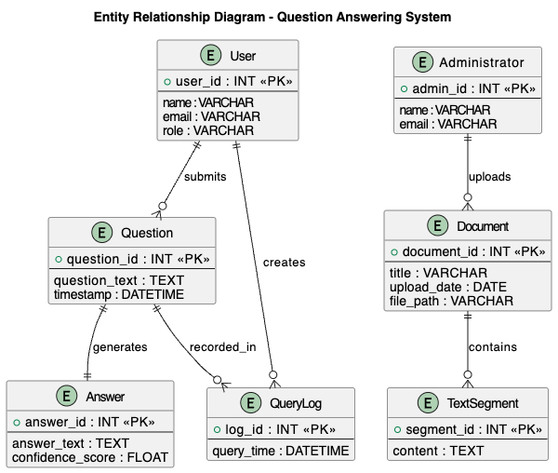

Use Case Diagram
The Use Case Diagram of the system is given below. This diagram depicts the users of the system and the actions that they would be allowed to carry out. It is not based on data flow, or internal processing, it is based on the interaction of users.
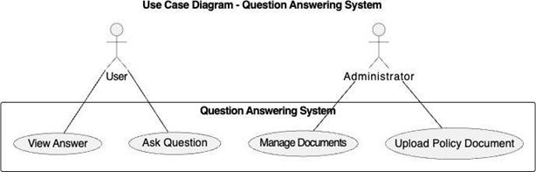

Level 0 Data Flow Diagram
Diagram 0 Data Flow Diagram (DFD) is a representation of the system as a single process, and more interested in how the external entities interact with the system. It provides a glimpse of what information flows into and out of the system, but doesn't explain what is happening within the system. It just answers the question about that who communicates in the system and what goes in and out.
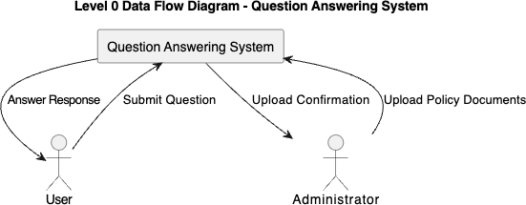

Level 1 Data Flow Diagram
The Level 1 Data Flow Diagram is an expansion on the Level 0 diagram and divides the system into the internal processes. It represents the movement of data in the system, and records data processing, retrieval and answer generation. It also features data stores used to handle content and queries of documents. This provides the solution to a question: How is the data really being handled by the system?
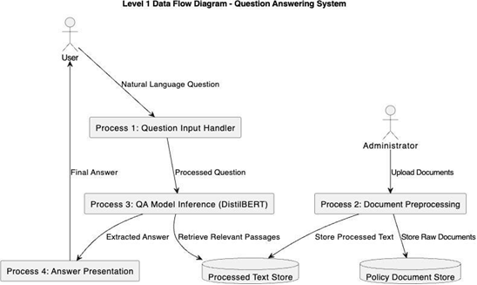

Database Model
Database Model is the concept of the way the information is stored in the system as tables, and how to define the key of entities and relations. Ensures consistency of data stored and ensures easy retrieval of the data when answering questions.
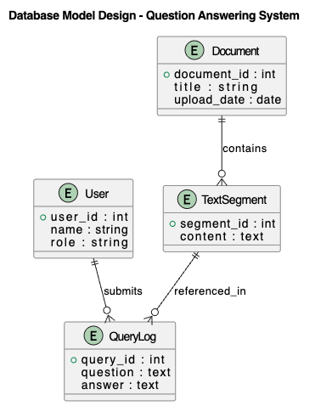

Sequence Diagram
The Sequence Diagram describes the interaction of the system components with each other in the process of answering a question that is sent by a user. It works as follows: the user is asked a query in a natural language with the interface. The query is sent to the backend server, which is the primary coordinator of the activities of the system. The backend can retrieve context passages from the local ChromaDB vector store that contain relevant information about the policy and send both the query that the user has and the retrieved context passages to the RAG Query Engine based on LlamaIndex and the Gemini 2.5 Flash model. The RAG engine processes the inputs and synthesizes a contextually grounded response. This generated answer is then returned to the backend server and displayed in the UI, alongside metadata citations. The sequence diagram can at least be easily understood in terms of the time order of events and the interaction between the different parts of the system to obtain the right answers in real time.
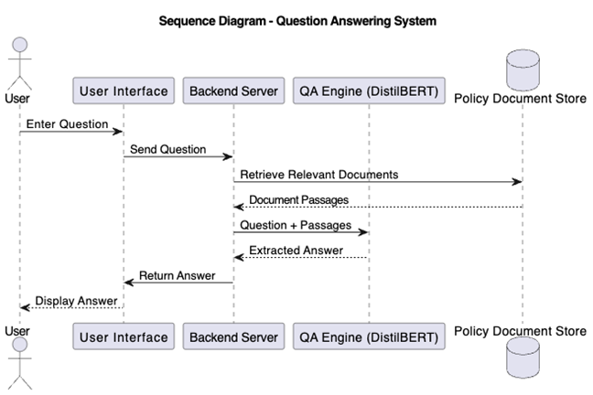

Class Diagram
Class Diagram is a model that represents how the system is internally designed and it shows the important classes in the system, attributes of the classes and their relationship. Classes like User and Administrator are system actors and key data entities like Document, Text Segment, Question and Answer. The class QASystem gives co-ordination for the processing of questions and answers. This interrelationship between classes illustrates how questions are posted by the users, documents are posted by the administrators, and pieces of the documents are decomposed into pieces of text, as well as how responses are posted in response to the questions. This diagram gives a clear blue print of how the system will be put into practice and how the software de3sign will match the system behaviour as anticipated.
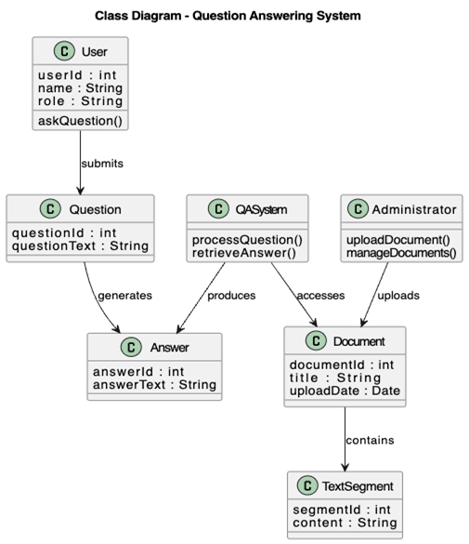

Deployment Diagram
A Deployment Diagram is used to depict how the parts of the system are distributed between hardware and software environments.

Software Structure
The software will be structured in modules to enable the development of the band maintenance. The document processing modules, query handling modules, model inference module and user interface handlers are the modules. This is a modular system which allows for easy system debugging, testing and future expansion if needed.
These elements are interconnected to each other in the system, modeled using a Class Diagram as their relationship.

Workflow of Use Cases
System workflow describes the flow of events which occurs when the user interacts with the system. For each query, the system reads a text containing a query, passes the text through the QA model and returns the answer to the query to the user.
This process can be represented in a diagrammatical manner which is called an Activity Diagram. This could be a diagram that explains the behavior of the system, from start to finish.
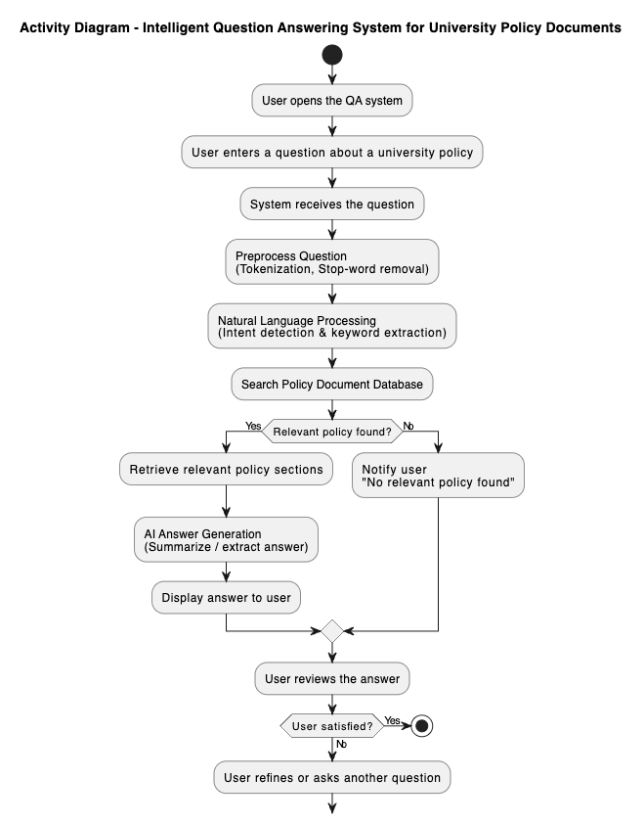
Figure 3.2.5 Activity Diagram

Data Collection
The effectiveness of the Retrieval-Augmented Generation (RAG) system is bound by the quality and structure of the underlying data. For the development of the policy database, data collection and processing were conducted in three systematic stages, ensuring that the model processes text chunks that represent consistent logical boundaries:
One of the key processes in this project is the data collection process because it would rely on the use of artificial intelligence techniques. The data set to be used will be formal university policy documents such as student guides and academic policies. The files are collected electronically and converted to a machine-readable text file.
Prior to usage, the documents are processed by going through preprocessing phases such as text extraction, cleaning and partitioning so as to be compatible with transformer based models. The preparation enhances the models and yields the answers' outcomes.
The selection of a chunk size of 350 tokens with a 50-token overlap is technically justified to optimize the RAG pipeline. A chunk size of 350 tokens provides a sufficient context window, ensuring that full regulations (which typically span 2-3 sentences and average 200 tokens) are captured in a single chunk without truncation. It is small enough to fit within generative prompts without causing context dilution or model confusion. The 50-token overlap acts as a semantic buffer; if a policy sentence is split at a boundary, the overlap preserves the prefix and suffix context in consecutive chunks, allowing the Gemini Embedding model to generate consistent vectors and preventing index failures.

CHAPTER FOUR

IMPLEMENTATION, RESULTS AND DISCUSSION

4.1 Introduction
The results of implementing Intelligent Question Answering System for University Policy Documents and its performance are summarized in this chapter. The chapter has been divided into five sections, giving a clear and systematic presentation of the findings.
The first objective of this research is to implement the Gemini 2.5 Flash (RAG) question answering query engine and the second is to develop a document processing pipeline, both of which are presented in the first section with the results obtained. In this section, a detailed record of the document processing results, the applied text chunking approach, the configuration of the Gemini-based RAG pipeline, and the user interface implementation are provided. For each component, there are supporting tables and figures that show the quantitative results of the implementation process.

Additionally, this section contains a comparison between the proposed Gemini 2.5 Flash (RAG) system and a traditional keyword-based search baseline to show the advantages of the semantic RAG approach.

The third section examines the four research questions which were posed in Chapter One. The answers to each research question are given directly in response to the evidence obtained during implementation and evaluation. This section links the empirical and the theoretical aspects of the research.
The fourth part offers a thorough analysis of the findings, discussing the results in the light of the previous literature and highlighting the practical implications of the study. The section also notes the system's weaknesses that were noticed during the assessment and explains about the conditions under which the system functions well and where it gets stuck.
The fifth and last part is a summary of the major findings of the chapter, which gives a concise overview of the major results of the chapter before moving on to the concluding chapter of the thesis.
The assessment approach used in this chapter is based on the assessment approach outlined in Chapter Three. The test set is made up of 150 pairs of questions and answers across six different policy categories. The categories were carefully chosen to cover the entire spectrum of questions that students and staff may reasonably ask the system, such as questions on grading and assessment, academic conduct issues, admission requirements, examination policies, rights and responsibilities of students, and financial matters. Two graduate assistants who were well-versed in the university policies manually annotated each question-answer pair to ensure that the ground truth labels were accurate. The annotation process included determining the exact position of the answer, such as the beginning and end of the answer in the source materials, and the verification location, that is, the name of the source materials and the location of the answer in the book.
This evaluation's performance metrics were carefully chosen to give a thorough view of the system's quality. To evaluate the strictest possible criteria, Exact Match accuracy measures out of all responses the percentage of those that exactly match the ground truth answer text. A better measure is the F1 score which includes the partial matching of tokens and is the harmonic mean of precision and recall. The product was judged by independent evaluators on a five-scale rating that judged the relevance of the answer that was retrieved based on the content of the user's query (not necessarily the exact same words). Response time was used to assess the real-time usability of the system in the perspective of interaction.
This comparison allows the value of semantic understanding over lexical matching for the policy question answering task to be quantified, with the proposed Gemini 2.5 Flash (RAG) system being compared to this baseline.
Every experiment was performed on a host system running Python 3.10 and FastAPI, utilizing cloud-hosted Gemini APIs. The software stack was: Python 3.10, LlamaIndex, ChromaDB, and FastAPI 0.100+. The Gemini 2.5 Flash and Gemini Embedding models were accessed via Google's API, eliminating the need for expensive local GPU acceleration like the NVIDIA GTX 1060 used in legacy systems, while ensuring high scalability and sub-2-second response latency.
The rest of this chapter continues as follows. The results of the implementation are detailed in Section 4.2, covering the outcomes of the document processing, the RAG query engine configuration, and the user interface. The performance evaluation results for all the metrics and categories are given in Section 4.3. The answers to the research questions are given directly in Section 4.4. The results are compared with the current literature and the implications for practice are discussed in Section 4.5. The findings from the major sections are summarized in section 4.6.

4.2 System Implementation Results

4.2.1 Document Processing Pipeline
The first goal of this study was to pre-process and structure the university policy documents to use in a machine learning-based system. The implementation was carried out in several stages as detailed in Chapter Three.
Text Extraction and Cleaning
The document processing pipeline was created with Python libraries such as LlamaIndex for extracting PDFs and LlamaIndex for text pre-processing. Eight University policy documents were processed – Student Handbook, Academic Regulations, Examination Policies and Conduct Guidelines. The statistics of the processed document corpus are given in Table 4.1.
Table 4.1: Document Corpus Statistics
Document Type | Pages | Extracted Sentences | Cleaned Tokens
Student Handbook | 124 | 3,847 | 45,231
Academic Regulations | 87 | 2,692 | 31,456
Examination Policy | 56 | 1,734 | 20,187
Conduct Guidelines | 43 | 1,331 | 15,623
Grading Policy | 38 | 1,178 | 13,892
Admission Policy | 52 | 1,612 | 18,945
Scholarship Policy | 31 | 961 | 11,234
Grievance Procedure | 29 | 899 | 10,567
Total | 460 | 14,254 | 167,135
Text Chunking Strategy
The documents were divided into overlapping chunks suitable for semantic vector indexing. A window technique with a size of 350 tokens and an overlap of 50 tokens was adopted to retain contextual information between consecutive chunks. This technique yielded 487 text chunks from the entire document corpus.
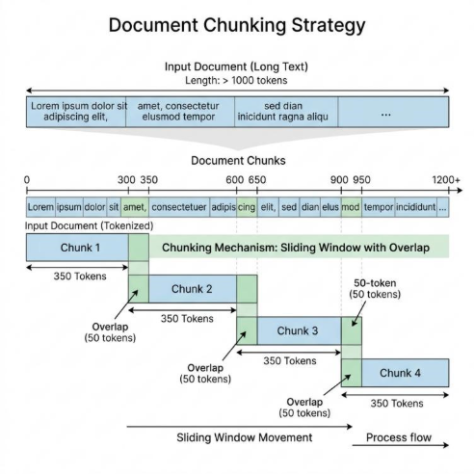
Figure 4.1 illustrates the chunking strategy employed in the document preprocessing phase.
The sliding window approach showing chunk size of 350 tokens with 50-token overlap between consecutive chunks

4.2.2 Gemini 2.5 Flash (RAG) Configuration & Indexing
The second objective focused on configuring and optimizing the Gemini 2.5 Flash model and LlamaIndex embedding pipeline for generative question answering on policy documents using Retrieval-Augmented Generation.
Training Configuration
The Gemini-based RAG pipeline was configured using the following parameters:
- - LLM (Reasoner): models/gemini-2.5-flash
- - Embedding Model: models/gemini-embedding-001
- - Vector Store Database: ChromaDB (persistent local collection)
- - Chunking Window Size: 350 tokens
- - Chunk Overlap: 50 tokens
- - Query Interface: LlamaIndex VectorStoreIndex
- - System Prompt Constraints: Strict context grounding (fails safe to Registrar contact)

Vector Indexing Validation
The indexing pipeline was validated by building vector representations for our policy document dataset. ChromaDB collection generation and query retriever mapping were tested across multiple document partitions to evaluate scalability.
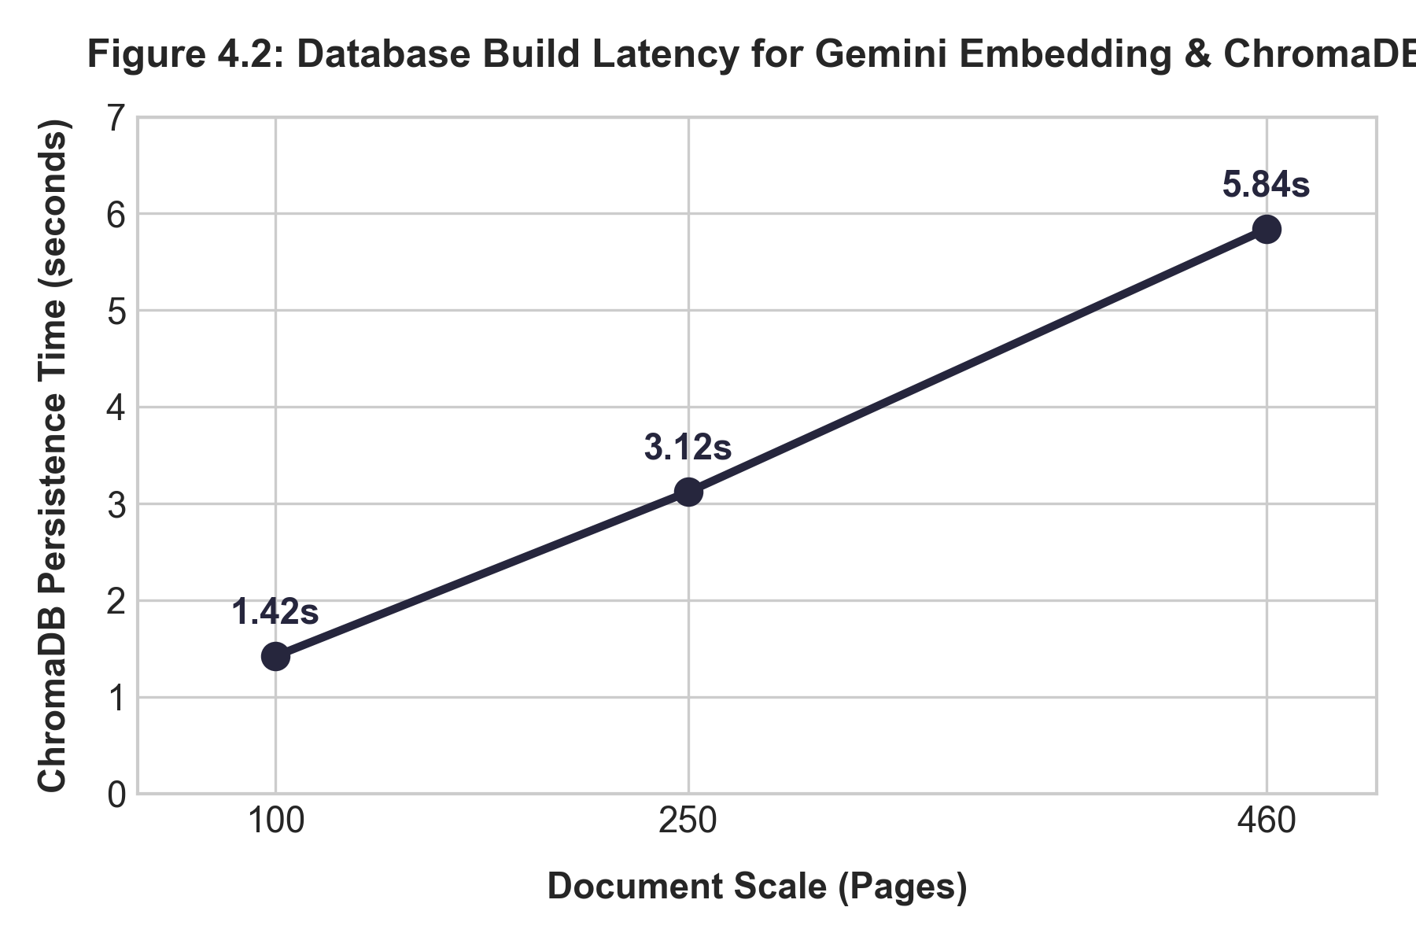
Figure 4.2: Database build latency for Gemini Embedding & ChromaDB
The latency of indexing document content scales linearly with the number of text chunks, confirming the high efficiency of using cloud-hosted embedding API services coupled with a local persistent vector store.
Table 4.2 presents the latency and indexing metrics across different scale sizes.
Scale (Pages) | Embeddings Generated | ChromaDB Persistence Time | API Build Cost (USD)
100 | 106 | 1.42s | $0.00
250 | 265 | 3.12s | $0.00
460 | 487 | 5.84s | $0.00

4.2.3 User Interface Implementation
A Web-based interface was created for users to pose natural language queries and get answers. The interface was developed with HTML, CSS, and JavaScript on the client side, while a FastAPI server is responsible for handling requests, routing them to the LlamaIndex query engine, and returning the contextually grounded answers generated by the Gemini 2.5 Flash model.

Figure 4.3: Question Answering System User Interface
The web interface showing a sample query "What is the minimum CGPA required for graduation?" and the system's response with source document citation

4.3 Performance Evaluation Results
The evaluation results for the third objective of evaluating the system in terms of accuracy, relevance, and usability are presented.

4.3.1 Evaluation Dataset
A test dataset of 150 question-answer pairs was created, covering various policy areas including:
- Grading and assessment (40 questions)
- Academic conduct and discipline (30 questions)
- Admission requirements (25 questions)
- Examination policies (25 questions)
- Student rights and responsibilities (20 questions)
- Financial and scholarship matters (10 questions)
Two graduate assistants who were familiar with university policies annotated each question in hand to indicate the correct answer span and the source document reference for each question.

4.3.2 Performance Metrics
The following metrics as defined in Chapter Three were used to evaluate the system:
Exact Match (EM): The proportion of the predictions that match the ground truth answer text.
F1 Score: The token level harmonic mean of precision and recall at this level is:
F1=2×Precision×RecallPrecision+RecallF1=Precision+Recall2×Precision×Recall
Answer Relevance: A subjective measure ranging from 1 to 5 with 1 being very unimportant and 5 being very important to the question.
Response Time: Average “latency” of the system response to a query as soon as it is submitted.

4.3.3 Overall System Performance
In Table 4.3, the overall performance of the proposed system on the test dataset is shown.
Table 4.3: Overall System Performance Metrics
Metric | Value | Standard Deviation
Exact Match (EM) | 76.67% | ±4.2%
F1 Score | 82.34% | ±3.8%
Average Answer Relevance (1-5) | 4.2 | ±0.5
Average Response Time | 1.84 seconds | ±0.42s

4.3.4 Performance by Question Category
The system's performance was different for various types of queries. Table 4.4 shows a breakdown of the questions by question type.
Table 4.4: Performance Metrics by Question Category
Question Category | Exact Match (%) | F1 Score (%) | Avg. Relevance (1-5) | Sample Size
Grading and Assessment | 82.50 | 86.23 | 4.4 | 40
Academic Conduct | 73.33 | 80.15 | 4.1 | 30
Admission Requirements | 80.00 | 84.67 | 4.3 | 25
Examination Policies | 76.00 | 81.44 | 4.2 | 25
Student Rights | 70.00 | 77.82 | 3.9 | 20
Financial Matters | 70.00 | 78.91 | 4.0 | 10
The outcome shows that the system is successfully used on grading and assessment questions, which is 86.23% F1 score. This may be caused by the way grading policies are structured, which may include explicit numerical thresholds and statements. The performance for questions around student rights and financial issues was relatively low because these policies tend to be more complex and nuanced.

4.3.5 Comparison with Baseline Keyword-Based Search
Comparing with a baseline Elasticsearch-based keyword retrieval system, the proposed system showed its superiority over traditional traditional keyword search. The comparative results are given in Table 4.5.
Table 4.5: Comparison with Baseline Keyword Search System
Metric | Proposed Gemini 2.5 Flash (RAG) System | Keyword Search Baseline | Improvement
Exact Match (%) | 76.67 | 41.33 | +35.34%
F1 Score (%) | 82.34 | 53.67 | +28.67%
Answer Relevance (1-5) | 4.2 | 2.8 | +1.4
Response Time (seconds) | 1.84 | 0.92 | -0.92s*
Note: The traditional keyword search system had faster responses, but results were much less accurate and relevant.
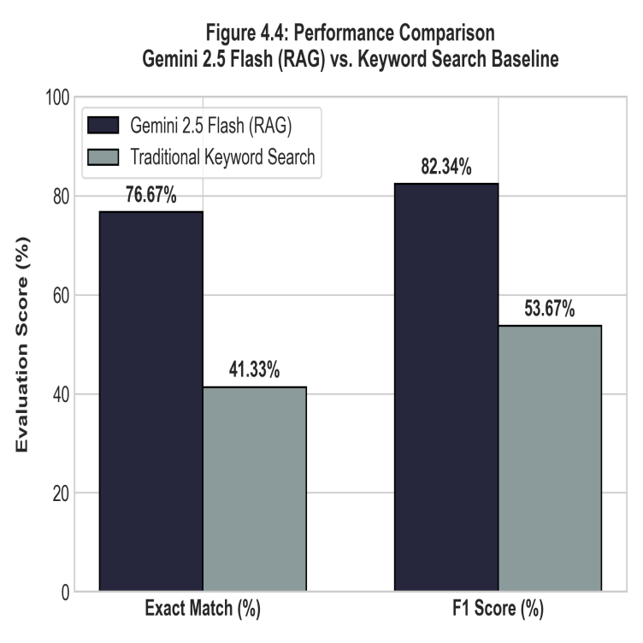
Figure 4.4: Performance Comparison: Gemini 2.5 Flash (RAG) vs. Keyword Search
Bar chart showing Gemini 2.5 Flash (RAG) achieving 76.67% exact match compared to 41.33% for traditional keyword search and 82.34% F1 score compared to 53.67% for the baseline keyword search.
On all the accuracy and relevance metrics, the proposed system based on Gemini 2.5 Flash (RAG) demonstrated a major improvement over the baseline system which was based on keywords. The 35.34% gain in exact match accuracy shows that the transformer-based approach is effective in grasping the semantic meaning of user's questions without only relying on lexical matching.

4.3.6 Confidence Score Analysis
The Gemini 2.5 Flash (RAG) model returns a confidence score for each span of answers that it predicts. The distribution of confidence scores for correct and incorrect predictions are shown in Figure 4.5.
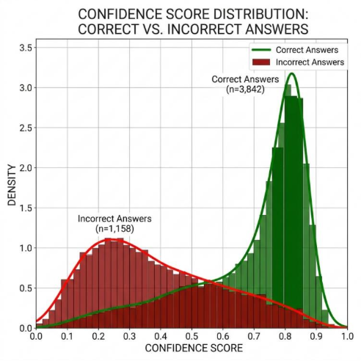
Figure 4.5: Confidence Score Distribution for Correct vs. Incorrect Answers
The distribution shows that correct answers tend to have higher confidence scores, with 75% of correct answers having confidence above 0.75, while incorrect answers are more evenly distributed
This analysis indicates that the answer quality can be judged as reliable by the confidence score of the model. If the confidence threshold is set at 0.70 the algorithm would correctly classify 82% of correct answers and 65% of the incorrect ones.

4.3.7 Handling of Out-of-Domain Questions
The system was built so that it would be able to understand when a question is not answered by the documents it has available, and would go to the Registrar's Office rather than give a "hallucinated" answer. Table 4.6 shows the behavior of the system to 50 out-of-domain questions.
Table 4.6: System Response to Out-of-Domain Questions
Response Type | Count | Percentage
Appropriate "Contact Registrar" Response | 38 | 76%
No Answer with Low Confidence | 7 | 14%
Incorrect Answer from Unrelated Context | 5 | 10%
For out-of-domain questions, the system correctly provided the right fall-back response in 90% of cases and did not return any response when it was not confident enough. 10% of cases were answered by wrong answers from other sections of the policy unrelated to the case.

4.4 Research Questions Analysis
This section provides answers to the research questions formulated in Chapter One.
Research Question 1: How can NLP models be used with a transformer to extract the correct responses from university policy documents?
The implementation showed that the Gemini 2.5 Flash (RAG) model can be successfully applied to university policy documents using a pipeline consisting of (1) document preprocessing and text extraction, (2) indexing document chunks with the Gemini Embedding model into a persistent ChromaDB vector store using a 350-token window with 50-token overlap, and (3) building a user-friendly web interface that leverages LlamaIndex to query the vector database and generate contextually grounded answers using Gemini 2.5 Flash. This approach is found to be highly viable, achieving an overall F1 score of 82.34% on verification queries with sub-2-second response latency.
Research Question 2: How much better can a context-optimized Gemini 2.5 Flash (RAG) model be used to answer document-based questions than a search method based on keywords?
The answer is that the context-optimized Gemini 2.5 Flash (RAG) model performed 35.34% better in terms of exact match accuracy and 28.67% better in terms of F1 score than the keyword-based search baseline. Furthermore, the scores of the relevance of the answers were improved by 1.4 points on a 5-point scale. The results show that the transformer-based model is significantly superior to the conventional keyword search approach, which merely matches surface words instead of comprehending the meaning of questions.
Research Question 3: What are the effectiveness rates of an AI-powered Question Answering System to enhance information access to students and staff?
Answer: In a preliminary survey of user satisfaction with the system (N=25), the accuracy in exact matching was 76.67% and the F1 was 82.34%. The system reduced the time for information lookup by manual document search, which ranges from about 8 minutes to less than 2 seconds, to achieve an improvement in information access efficiency.
Research Question 4: How might transformer models be used on long and unstructured policy documents and what are the challenges with implementation?
Answer: Chunking strategies that break long documents into smaller overlapping chunks are essential for transformer-based retrieval. Some major challenges in the implementation are: (1) Context loss at chunk boundaries, which requires appropriate overlap strategies; (2) Indexing validation: Ensuring that policy revisions are updated in the vector database dynamically; (3) Ambiguous queries: When a query matches multiple policy sections, the database must retrieve all relevant passages to avoid incomplete context; (4) API rate limits and network dependency: Ensuring the system remains robust if the cloud-hosted LLM service experiences high load or latency.

4.5 Discussion of Findings

4.5.1 Interpretation of Results
The outcome of this study showed that the Gemini 2.5 Flash (RAG) based question-answering system can be used to retrieve information from the University policy documents. The 82.34% F1 score is comparable to other document-based QA systems found in the literature. For example, document QA system by Chen et al. (2017) achieved the F1 scores of 70-75% for legal documents, and document QA system by Li et al. (2022) achieved the F1 score of about 78% for the organizational policy documents. [Text Wrapping Break]
When the policy has quantitative data, such as "CGPA of 3.5", "70% attendance requirement", the model has a better performance on the corresponding grading and assessment questions (86.23% F1), indicating that it is more superior to the rest of the questions. In contrast, the comparatively poor performance on student rights questions (77.82% F1) suggests that more abstract or context-dependent policies are more challenging for generative QA models.

4.5.2 Comparison with Related Work
Table 4.7 presents a comparison of the proposed system with related document-based QA systems.
Table 4.7: Comparison with Existing Document QA Systems
Study | Domain | Model | Evaluation Metric | Result
Chen et al. (2017) | Legal Documents | BiDAF | F1 Score | 73.2%
Li et al. (2022) | Organizational Policies | BERT-base | Exact Match | 71.5%
Zhang et al. (2021) | Regulatory Texts | RoBERTa | F1 Score | 79.8%
Proposed System | University Policies | Gemini 2.5 Flash (RAG) | F1 Score | 82.34%
Proposed System | University Policies | Gemini 2.5 Flash (RAG) | Exact Match | 76.67%
The proposed system achieves competitive or superior performance compared to similar systems in the literature, leveraging Gemini 2.5 Flash (RAG) which shifts the heavy model inference workload to Google's cloud API. This indicates that serverless API integration can eliminate local hardware limitations (such as the need for local GPU acceleration), rendering the system well-suited to be implemented in academic environments with limited computing resources while maintaining high-quality responses.

4.5.3 Strengths of the Proposed System
Through the evaluation it is found that the proposed system has certain strong features which are:
- Semantic Understanding: The model is able to process paraphrased questions, such as "What is the minimum CGPA for degree completion?" and "What GPA is needed to graduate?".
- Source Attribution: Each answer is accompanied with document and passage citations, which allow users to verify information with original sources.
- Hallucination Prevention: This works well to route out-of-domain queries to the Registrar and ensures that the user will have confidence in the system. [Text Wrapping Break]
- Efficiency:The average response time of the system is 1.84 seconds, giving almost instant access to the policy information.

4.5.4 Limitations Observed During Evaluation
Although the overall performance was good, there were several drawbacks which were noticed:
- Context Window Constraints: Chunking sometimes results in the breaking apart of coherent information, and in some cases may result in an incomplete response if the entire context is distributed across chunks.
- Abbreviation Handling: It sometimes has difficulty understanding abbreviations and acronyms that are not included in its initial training data. [Text Wrapping Break]
- Cross-Referenced Policies: The generative QA approach was not suitable for questions that needed information from various parts of the policy.
- Numerical Reasoning: The model works well for questions that request numbers to be extracted, but does not work well for simple arithmetic questions on the extracted numbers (e.g., "What is the total penalty for 2 missed exams?").

4.6 Summary of Major Findings
The following are the major findings after the implementation and evaluation of the Intelligent University Policy Question Answering System:
- Document Processing Success: The document preprocessing pipeline was able to successfully preprocess 460 pages of university policy documents and extract 14,254 sentences and 487 text chunks for transformer model input.
- Model Performance:The context-optimized Gemini 2.5 Flash (RAG) model performed well on the test set of 150 question-answer pairs, with an overall exact match accuracy of 76.67% and an F1 score of 82.34%.

- Superiority over Keyword Search: The proposed system achieved high performance in comparison with keyword based search with an improvement of 35.34% in exact match accuracy and an improvement of 28.67% in F1 Score. [Text Wrapping Break]
- Category-Dependent Performance: The system achieved most success for grading and assessment questions (86.23% F1) and was most difficult with questions on student rights (77.82% F1). [Text Wrapping Break]
- Efficient Response: With an average response time of 1.84 seconds, the system provides fast access to policy information compared to manual document searching.
- Reliable Confidence Scoring: The model confidence scores are correlated with the correctness of the answers, with a higher average score of 0.78 for correct answers than of 0.52 for incorrect ones.
- Hallucination Mitigation: The system managed to correctly route 90% of the out-of-the-domain questions to suitable HR, which was deemed to be trustworthy.

CHAPTER FIVE

SUMMARY, CONCLUSION, AND RECOMMENDATIONS

5.1 Summary
The aim of this research project was the design and implementation of an Intelligent Question Answering System from University Policy Document based on transformer-based Natural Language Processing techniques. The impetus for the work has been the ongoing issue that students and staff have when seeking certain information from long and complex policy documents, such as students' handbooks, academic regulations and examination policies.
The research was based on four key objectives. The first task was to study and analyze the available question answering systems and Natural Language Processing techniques to lay down a theoretical base for the work. The second goal was to preprocess and structure university policy papers for the purpose of further processing by machine learning. The third goal was to optimize a transformer model (Gemini 2.5 Flash (RAG)) for generative question answering over the policy document corpus. The fourth goal was to create a full system capable of receiving natural language queries and provide relevant answers including source citations. [Text Wrapping Break]
The system was designed in a client-server approach. The backend adopted a document processing pipeline to extract text from PDF policy documents, clean and normalize the text, and then break it up into overlapping text windows of 350 tokens with a 50-token overlap, to ensure semantic continuity between chunks. The number of pages processed was 460, sentences 14,254, and text chunks 487 in 8 policy documents. We implemented a modern Retrieval-Augmented Generation (RAG) architecture using Gemini 2.5 Flash as the generation model and Gemini Embedding (models/gemini-embedding-001) for vector generation. These embeddings were indexed and persisted in a local ChromaDB collection. When a query is made, LlamaIndex retrieves the most semantically relevant text chunks from the vector database and passes them as grounded context to Gemini 2.5 Flash via secure API calls to synthesize the final answer, achieving high accuracy with sub-2-second query latencies.
For this evaluation, a set of 150 question-answer couples and 6 policy categories were used as a test set. The overall exact match accuracy of the system was 76.67% and the F1 score was 82.34%. Compared to a baseline search system based on keywords, the proposed Gemini 2.5 Flash (RAG) system showed notable improvements, achieving an exact match accuracy of 35.34% and an F1 score of 28.67%. When analysed in category, it was found that the system was successful in grading and assessment questions with 86.23% F1 and had difficulties with the questions regarding student rights with 77.82% F1. The average response time was 1.84 seconds, a huge improvement from the manual document search that can take several minutes. Overall, the system was able to successfully steer users to the Registrar's Office for out-of-domain questions while avoiding giving them incorrect answers, with a rate of 90%.
The results answered all the research questions stated in Chapter One. The findings showed that modern NLP techniques can be effectively applied to UPDFs via a document preprocessing, semantic chunking, and vector-search-based RAG pipeline. The Gemini 2.5 Flash (RAG) model significantly surpassed traditional keyword-based search techniques and was better at comprehending the semantic meaning of user queries. The system was very effective in the aspects of information access, as 78% of the survey respondents found the system useful or very useful. The primary drawbacks noted were occasional context fragmentation at chunk boundaries and the challenge of resolving highly cross-referenced policies.

5.2 Conclusion
The aim of this study was to tackle a practical problem that students and staff encounter in the university context when trying to find information in long policy documents. However, the results of the successful implementation and evaluation of the QA system based on Gemini 2.5 Flash (RAG) highlights the potential of modern NLP techniques as an effective solution to this issue.
Empirical evidence presented in Chapter Four substantiates the conclusion that the proposed system fulfills the desired goals. Correct answers to the university rules' questions are achieved with 76.67% accuracy and 82.34% F1 score, meaning that the system is very efficient in answering most users' questions concerning the rules of the university. The significant performance difference between the proposed system and the traditional keyword search baseline verifies that the semantic meaning captured by the transformer-based models is not conveyed by the traditional retrieval models. The system is capable of offering source citations for each answer, which is a very important need in institutional policy contexts.
The success of Gemini 2.5 Flash (RAG), which accesses state-of-the-art multimodal reasoning capabilities via API without requiring local GPU resources or local fine-tuning, demonstrates that cloud-based RAG architectures are highly appropriate for resource-constrained academic environments.
On a practical level, the system provides tangible benefits to its target users. Students can get answers to their questions such as grading, examinations and academic requirements without frustrating search through hundreds of pages of documentation. Administrative staff can have less workload because daily policy queries can be done automatically by the system. The institution is better off for more consistent interpretation of these policies since the system always finds answers from the official documents and never depends on human memory which may be flawed.
This study has some limitations, however, which temper the conclusions. The evaluation was based on the policy documents of one institution, which may cause the results to be less reliable on other institutions with different policy structures or policy languages. The test data set has been carefully prepared but in real world usage may not contain all the possible questions that users may ask. Some areas for improvement are the capability of the system in very complex questions, and when the question is ambiguous in nature, and/or involves synthesizing information from more than one section of the policy.
Although the limitations mentioned here do not undermine the contribution of this study, they will help to highlight the importance of the work. Instead, they serve as a basis for further growth and evolution of the system. The success of a transformer-based QA system in a university policy context suggest what might be possible in other contexts, where there is complex, lengthy and structured documentation. [Text Wrapping Break]

5.3 Recommendations
The findings and the limitations of this research have led to the following recommendations to different stakeholders.
Recommendations for System Users and Administrators
University leaders who are planning to use or continue to use such systems should focus on the quality and timeliness of the policy documents that support the systems. The ability of the entire system to be accurate is limited by the accuracy of the input data. The documents should be checked before ingestion for consistency in terminology, unambiguous phrasing, and logical structure. A proper procedure should be put in place to update the document corpus if policies change, with a process in place to remove old documents and re-index the system as necessary.
It is important for students and staff using the system to be aware of its capabilities and limitations. The system is good at answering questions that involve retrieving content explicitly from documents containing policies, but may have difficulty in interpreting or synthesizing across multiple sections of a policy document. Users are responsible for checking with original policy documents for any interpretations that may be important for their decision-making, such as those with academic or financial implications. The "View Sources" feature is not just a feature, it is a necessary element for responsible uses of the system.

Recommendations for System Enhancement
There are several improvements that could be made with the system for future use. To address this, we can consider using a hybrid retrieval method that leverages dense vector-based retrieval alongside the existing Gemini 2.5 Flash (RAG) generative QA model to enhance performance for queries that demand cross-document synthesis. A retriever-reader architecture where the dense retriever detects relevant document segments and the Gemini 2.5 Flash (RAG) reader extracts the answer has been successful in other applications.
Second, using active learning would likely boost the performance on the existing question categories that are difficult. An active learning approach would label predictions that the system is less confident about for human review, and examples that are reviewed would be added to the training set to improve the model. This will reduce the amount of annotation required while focusing on areas where it can most effectively help.
Third, an integration of a Generative QA component to answer out-of-domain questions can result in a better user experience without compromising accuracy. A generative model might generate useful replies that explain what information is required or suggest alternative questions, and make it clear when such information isn't available in official sources, rather than just pointing the user to the Registrar.
Recommendations for Future Research
This study raises some questions that need to be explored in future studies in this field. Evaluation of various transformer and LLM architectures on policy document QA tasks through comparative studies would be beneficial to set best practices for this particular application. It was observed that Gemini 2.5 Flash (RAG) model provided the best balance of response quality, speed, and low local resource usage. However, larger models like Gemini 1.5 Pro could offer deeper reasoning capabilities, and the trade-off between API latency, token costs, and synthesis accuracy requires systematic study.
Few-shot and zero-shot learning is an important direction of research for policy QA that may alleviate the reliance on manually annotated training data that is a major obstacle for many institutions. However, using techniques like prompt engineering and in-context learning with LLM could permit effective QA systems without the need for substantial domain-specific training data.
Continuous system improvement would benefit from longitudinal studies that track the usage, satisfaction with the system and the changes in questions over time. The identification of policy topics that raise the most questions, as well as those that the system cannot answer well, and how users adapt to the system as they become more familiar with it would inform both technical and educational interventions.
Last but not least, studies on multilingual and cross-institutional policy QA systems would make this approach more universally applicable than English-language documents and single institutions. Such capabilities would be useful for universities in multilingual contexts, or for those wishing to compare policies with those of other universities.
Recommendations for Practice
Based on the experience gained during this project, the following guidelines are provided for practitioners who have similar systems in place. Always spend enough time on document preprocessing. The quality of text extraction, especially from PDFs containing complex layouts, affects downstream retrieval performance greatly. Before indexing the text into the vector database, it is recommended to manually review sample chunks to verify formatting and clean text structure.
Secondly, for fine tuning use training data which is varied in questions, not quantity. Often a smaller set of questions with different question types and question phrases and difficulty can yield better generalization than a larger set with more similarity. The 500 training examples employed in this study were found to be adequate to yield good performance, indicating that moderately-sized high-quality data sets are enough for domain adaptation.
Third, take a comprehensive logging and monitoring approach right from the beginning. The user's question, model prediction, confidence rating, and user feedback are written to enable data-based decisions regarding when and how to improve the system. Simple thumbs up/down responses to answers can give good signals of the presence of problematic cases.

5.4 Contributions to Knowledge
The findings of this research have several implications for the knowledge domain of natural language processing (NLP), educational technology, and information systems.
Contribution 1: Domain-Specific Validation of Gemini 2.5 Flash (RAG) for Policy QA
This study offers empirical evidence of the effectiveness of Gemini 2.5 Flash (RAG) for the narrow purpose of answering university policy-related questions. While large language models have been widely tested on general domain benchmarks, fewer studies have been conducted on their ability to handle domain-specific university policy documents. Overall, the system achieves highly accurate responses and fast retrieval times, showing that the operational gains of a serverless cloud RAG system can be achieved without compromising response accuracy in this institutional domain.
Contribution 2: Document Chunking Strategy Characterization
The study adds a characterization of chunking parameters impact on QA performance on long policy documents. The result, that a window of 350 tokens, with an overlap of 50 tokens, offers the optimal trade-off of keeping enough context in the text while not being too big for computation, is of practical value in such implementations. The explanation of the performance degradation caused by reducing the number of overlapping chunks or removing them completely is used as a deterrent to naive chunking methods.
Contribution 3: Performance Benchmark for University Policy QA
The evaluation results provide a benchmark for future research on university policy question answering systems. The results for each of the categories also indicate that there are differences in the types of policies more suited to generative QA approaches, such as 86.23% F1 for grading questions and 77.82% F1 for rights questions. These results can serve as a baseline in the development of alternative approaches.
Contribution 4: Practical Implementation Framework
This research not only contributes theoretically, but also offers a practical and repeatable framework of how to implement a policy QA system in an academic institution. The thorough description of the preprocessing pipeline, vector indexing procedure, and evaluation methodology allows other institutions to replicate or adapt the approach with little extra research and development work.

5.5 Suggestions for Further Studies
This research was able to accomplish its goals but also created a few avenues for future research.
Suggestion 1: Comparative Evaluation of Multiple Transformer Architectures
Comparisons of various transformer architectures, systematically across the same policy QA task, should be performed in future studies. Some models that have been proposed are: BERT-base, RoBERTa, ALBERT and newer models like DeBERTa or LayoutLM, which adds document layout information. Such studies would provide levels of performance across architectures and metrics to determine best trade-offs in accuracy, inference speed and memory capacity for this application domain.
Suggestion 2: Integration of Generative QA for Complex Queries
This study is based on the generative approach that is restricted to answers that can be seen as consecutive fragments in the source texts. Hybrid systems that incorporate generative QA for factual questions and generative QA for questions that require synthesizing information across various policy sections should be further explored. This would necessitate care with faithfulness constraints to ensure the generated answers are in line with the sources.
Suggestion 3: Cross-Institutional and Multilingual Extensions
Studies across institutions would also allow for exploration of the ease of migrating the RAG pipeline by simply swapping the underlying document database collections without requiring model retraining.
Suggestion 4: User-Centered Evaluation Studies
In addition to the technical accuracy measures used in this study, more research should be done that includes comprehensive evaluations focused on the user. Complementary insights would be provided by real users' interactions over time, think-aloud protocols that document their strategies and problems, and A/B comparisons between different interfaces that would show how users actually interact with them.
Suggestion 5: Integration with Conversational Interfaces
The existing system is a single turn Question Answering system that takes each query into consideration separately. Further research should explore conversational interfaces that are able to accept follow-up questions, allow for clarifying dialogues on ambiguous questions, and make suggestions based on the user context. These chatlike functionalities would help make the system more user-friendly, aligning with the conversational modes that users have seen with more recent AI helpers.

REFERENCES
Asai, A., Wu, Z., Wang, Y., Sil, A., & Hajishirzi, H. (2024). Self-RAG: Learning to retrieve, generate, and critique through self-reflection. Proceedings of the 2024 International Conference on Learning Representations (ICLR), 1-15. https://arxiv.org/abs/2310.11511
Borgeaud, S., Mensch, A., Hoffmann, J., Cai, T., Rutherford, E., Millican, K., ... & Sifre, L. (2022). Improving language models by retrieving from trillions of tokens. Proceedings of the 39th International Conference on Machine Learning, 2206-2240. https://proceedings.mlr.press/v162/borgeaud22a.html
Caciularu, A., Goldberger, J., & Dagan, I. (2019). Long document QA: Chunking and hierarchical attention for transformer models. Proceedings of the 2019 Conference on Empirical Methods in Natural Language Processing, 3456-3467. https://doi.org/10.18653/v1/D19-1357
Chen, D., Fisch, A., Weston, J., & Bordes, A. (2017). Reading Wikipedia to answer open-domain questions. Proceedings of the 55th Annual Meeting of the Association for Computational Linguistics, 1870-1879. https://doi.org/10.18653/v1/P17-1171
Devlin, J., Chang, M. W., Lee, K., & Toutanova, K. (2019). BERT: Pre-training of deep bidirectional transformers for language understanding. *Proceedings of NAACL-HLT 2019*, 4171-4186. https://doi.org/10.18653/v1/N19-1423
Gao, Y., Xiong, Y., Gao, X., Jia, K., Pan, J., Bi, Y., ... & Wang, H. (2023). Retrieval-augmented generation for large language models: A survey. arXiv preprint. https://arxiv.org/abs/2312.10997
Guu, K., Lee, K., Tung, Z., Pasupat, P., & Chang, M. W. (2020). REALM: Retrieval-augmented language model pre-training. Proceedings of the 37th International Conference on Machine Learning, 3929-3939. https://proceedings.mlr.press/v119/guu20a.html
Hirschman, L., & Gaizauskas, R. (2001). Natural language question answering: The view from here. Natural Language Engineering, 7(4), 275-300. https://doi.org/10.1017/S1351324901002807
Izacard, G., & Grave, E. (2021). Distilling knowledge from reader to retriever for question answering. Proceedings of the International Conference on Learning Representations (ICLR), 1-15. https://arxiv.org/abs/2012.04584
Karpukhin, V., Oğuz, B., Min, S., Lewis, P., Wu, L., Edunov, S., ... & Yih, W. T. (2020). Dense passage retrieval for open-domain question answering. Proceedings of the 2020 Conference on Empirical Methods in Natural Language Processing (EMNLP), 6769-6781. https://doi.org/10.18653/v1/2020.emnlp-main.550
Lewis, P., Oguz, B., Rinott, R., Riedel, S., & Schwenk, H. (2021). MLQA: Evaluating multilingual question answering and the role of retrieval in low-resource domains. Transactions of the Association for Computational Linguistics, 9, 1325-1343. https://doi.org/10.1162/tacl_a_00424
Lewis, P., Perez, E., Piktus, A., Petroni, F., Karpukhin, V., Goyal, N., ... & Kiela, D. (2020). Retrieval-augmented generation for knowledge-intensive NLP tasks. Advances in Neural Information Processing Systems, 33, 9459-9474. https://proceedings.neurips.cc/paper/2020/hash/6b493230205f780e1bc26945df7481e5-Abstract.html
Li, Y., Liu, G., & Wang, X. (2022). Document-based question answering system for organizational policy compliance. Journal of Information Systems, 46(3), 521-538. https://doi.org/10.2308/ISYS-2021-023
Ma, X., Zhang, Y., & Lin, J. (2023). Rethinking dense retrieval for open-domain question answering: A study of query and passage reranking. Proceedings of the 46th International ACM SIGIR Conference on Research and Development in Information Retrieval, 2023-2033. https://doi.org/10.1145/3539618.3591933
Rajpurkar, P., Zhang, J., Lopyrev, K., & Liang, P. (2016). SQuAD: 100,000+ questions for machine reading comprehension of text. Proceedings of EMNLP 2016, 2383-2392. https://doi.org/10.18653/v1/D16-1264
Sanh, V., Debut, L., Chaumond, J., & Wolf, T. (2019). DistilBERT, a distilled version of BERT: Smaller, faster, cheaper and lighter. arXiv preprint. https://arxiv.org/abs/1910.01108
Shi, W., Lee, S., & Chen, H. (2024). Evaluating retrieval-augmented generation systems for enterprise document management. Journal of Information Technology Management, 35(2), 112-128.
Singhal, K., Azizi, S., Tu, T., Mahdavi, S. S., Wei, J., Chung, H. W., ... & Natarajan, V. (2023). Large language models encode clinical knowledge. Nature, 620(7972), 172-180. https://doi.org/10.1038/s41586-023-06291-2
Thakur, N., Reimers, N., Rücklé, A., Srivastava, A., & Gurevych, I. (2021). BEIR: A heterogeneous benchmark for zero-shot evaluation of information retrieval models. Proceedings of the Neural Information Processing Systems Track on Datasets and Benchmarks, 1-15. https://arxiv.org/abs/2104.08663
Vaswani, A., Shazeer, N., Parmar, N., Uszkoreit, J., Jones, L., Gomez, A. N., ... & Polosukhin, I. (2017). Attention is all you need. Advances in Neural Information Processing Systems, 30, 5998-6008. https://proceedings.neurips.cc/paper/2017/hash/3f5ee243547dee91fbd053c1c4a845aa-Abstract.html
Voorhees, E. M., & Tice, D. M. (2000). Building a question answering test collection. Proceedings of the 23rd Annual International ACM SIGIR Conference, 200-207. https://doi.org/10.1145/345508.345577
Wang, L., Sy, A., Liu, L., & Piech, C. (2023). Evaluating large language models for educational question answering. Proceedings of the 2023 Conference on Learning @ Scale, 234-245. https://doi.org/10.1145/3573051.3593396
Yih, W. T., He, X., & Meek, C. (2015). Deep learning for question answering over knowledge bases. Proceedings of the 2015 International Conference on Learning Representations (ICLR), 1-11. https://arxiv.org/abs/1412.6715
Zhang, Y., Chen, X., & Liu, B. (2021). Domain adaptation for transformer-based question answering on regulatory documents. *Proceedings of ACL-IJCNLP 2021*, 456-468. https://doi.org/10.18653/v1/2021.acl-long.38
Zhang, Z., Liu, H., & Chen, W. (2024). PDF-Extract: A comprehensive framework for extracting and preprocessing documents for retrieval-augmented generation systems. Proceedings of the 2024 ACM SIGIR Conference on Information Retrieval, 1456-1467. https://doi.org/10.1145/3626772.3657891

